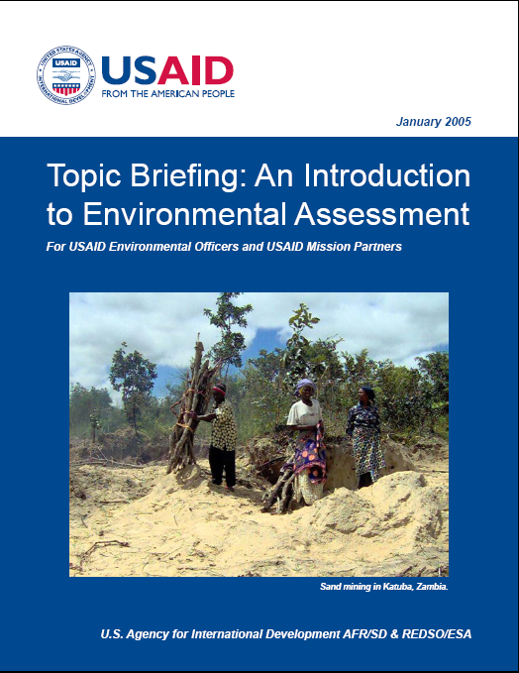

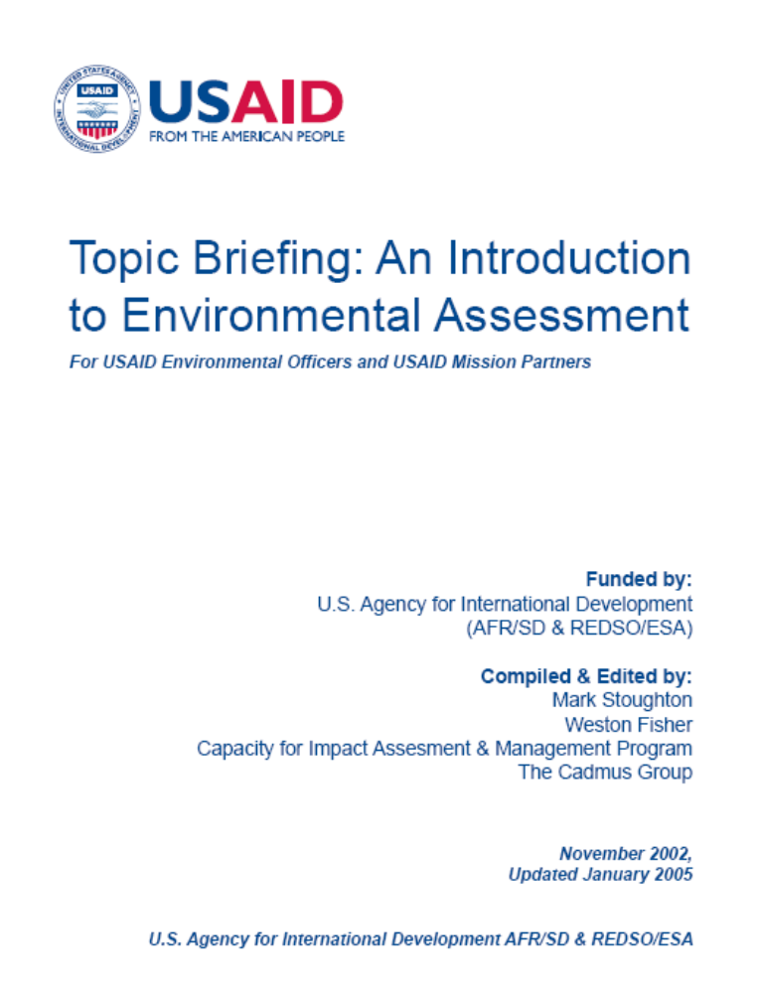

Table of Contents
Section 1. Basic concepts for assessing
environmental impacts 1-1
1.1. What is Environmental Impact Assessment? 1-1
1.2. Why assess? 1-1
1.3. Key definitions 1-3
1.4. Guiding goals and principles for EIA 1-4
1.5. The Generic EIA process 1-5
1.6. The EIA process and the project lifecycle. 1-8
1.7. Which stakeholders are involved in an EIA? 1-9
1.8. Resources required for preparing an EIA 1-9
1.9. Differing EIA requirements 1-11
1.10. Particular challenges of EIA in developing countries 1-12
Section 2. The EIA process in more detail 2-1
2.1. Introduction 2-1
2.2. Phase 1: Initial inquiries 2-1
2.3. Phase 2: the EIA itself 2-4
2.4. Communicating findings: sample outlines 2-9
Annex 2.A: Sample outlines of USAID and World Bank EIA documents 2-10
Annex 2.B: Screening criteria 2-13
Section 3. Information requirements and tools for
screening and preliminary assessment 3-1
3.1. Introduction 3-1
3.2. Information requirements 3-2
3.3. Tools for screening and preliminary assessment 3-3
3.4. Choosing tools 3-6
Section 4. Environmental monitoring and mitigation 4–1
Definitions and introduction 4–1
4.2. Mitigation: an overview 4–2
4.3. Monitoring: an overview 4–4
4.4. Integrated approaches to mitigation and monitoring 4–8
Annex 4.A: Excerpts from The Electronic Copy of The World Bank Environmental Assessment Source Book on Environmental Mitigation 4–10
Annex 4.B: Types of monitoring 4–12

Basic concepts for assessing
environmental impacts

In this section, we introduce the general terminology and concepts needed to conduct environmental assessment of programs, projects or activities. The section also provides an overview of the EIA process and the resources it requires.
Note: Much of the material is general, and can be enriched by the experiences of local experts and project developers with environmental impact assessments in their own country.

What is Environmental Impact Assessment?
Environmental impact assessment (EIA) is a formal process for identifying the likely effects of particular activities or projects on the environment and on human health and welfare.
The “environment” includes:
- The biological and physical environment
- The socioeconomic environment
EIA also encompasses the development of mitigation measures to address these impacts, and suggested approaches for implementing mitigation and monitoring measures.
NOTE: We use EIA here as a general term to avoid confusion with the specific environmental assessment (EA) procedures set out by USAID Regulation 216.

Why assess?
Conceptual motivation. Environmental impact assessment (EIA) helps improve the design of activities and their long-term sustainability or, to quote from Reg. 216, "to ensure that environmental factors and values are integrated into the decision-making process." This means that the environmental effects (both beneficial and adverse) of an action are considered along with other factors.

1.A Evolution of EIA
The first formal efforts to assess environmental impacts were conducted in the US in the early 1970s, in response to rising public concern over environmental deterioration. The passage of the (US) National Environmental Policy Act of 1969 (NEPA) mandated the EIA process for all projects involving federal actions, including the issuance of permits, licenses, and financial assistance. NEPA was intended to provide full and fair discussion of the significant environmental impacts of a planned action and to inform decision-makers and the public of the reasonable alternatives, which would avoid or minimize adverse impacts, or enhance the quality of the human environment.
In the years following NEPA, a number of states and municipalities in the U.S. enacted environmental policy acts mandating similar EIA requirements at local levels. As a result, an EIA in some form is likely to be required by statute for many development or redevelopment projects in the United States.
In the 1970’s, following concern over pesticide deaths in Pakistan associated with a USAID-funded activity, environmental groups sued USAID over its lack of compliance with NEPA. Regulation 216 and the environmental review procedures it requires, which form the basis for the present course, were formulated to address these concerns.
In the past several years, an increasing number of countries and multinational institutions have enacted laws and directives establishing EIA requirements for project reviews. In 1985, the European Economic Community issued a directive establishing minimum requirements for EIA in all member countries. The United Nations

1.A (cont’d)
Environment Programme adopted Goals and Principles of EIA in 1987. In 1991, twenty-six nations of the United Nations Economic Commission for Europe signed a Convention on EA in a Transboundary Context, requiring all signatory nations to establish EIA procedures for transboundary impacts.
Official aid agencies and the international banking community are also observing increasing emphasis on EIA. In 1989, The World Bank issued an operational directive requiring EIAs for certain categories of projects. Most multilateral development banks have now followed (or led) the World Bank in incorporating EIA procedures into their lending practices. Some national export credit agencies (ECAs) have also adopted EIA requirements.
A number of developing countries have recently adopted strategies and legislation calling for the establishment of EIA procedures and protocols, and plans are underway in several others. However, many have no specific environmental legislation.
An environmental assessment that is only an academic study is a failure. Environmental assessment exists to improve decision-making by ensuring that decisions improve the design and sustainability of proposed actions. EIAs must convey information about environmental impacts of projects and programs to those responsible for approving them—and it must do so at a stage when this information can materially affect the outcome. (Wathern 1988, 6) (CIDA, 1994).
While there has been criticism leveled at this process (see sidebar 1.A), there are few today who would seriously question the validity and usefulness of examining the environmental impacts of development projects.
Requirements of national governments and funding agencies. Today, environmental impact assessments are a legal requirement for major development projects with significant environmental impacts in most industrialized countries and in many developing countries.

In addition to legal requirements that may exist within the countries themselves, projects funded by most bilateral and multilateral funding agencies, such as USAID and the World Bank, must adhere to their own legal EIA requirements, which generally specify the need for initial environmental examinations or more thorough environmental impact assessments.

1.B Misconceptions about EIA
- EIA is anti-development. EIAs rarely lead to the cancellation of a project. EIA provides the decision-maker with environmental information, just as an economic feasibility provides economic information—they do not mandate decisions. An EIA can show a project to be environmentally unsound, just as an economic study may show a project to be economically unsound. Few rational observers would condemn economic analysis for this reason.
- EIA is too expensive or a waste of money. The median estimate for EIA cost is on the order of one-half to one percent of a projects construction cost. In Thailand, for instance, suggested allowances for EIA costs are from 0.1% to 1.1%, with higher percentages for smaller projects (less than $1 million US). The cost savings in improved project design and avoided environmental impacts is often many times this amount. In the long run, not doing an EIA can turn out to be far more expensive.
- EIA is ineffective. Common criticisms of EIAs are that they are carried out too late to affect decisions, and often simply justify decisions already taken. EIAs conducted too late in the decision process or as mere formalities are ineffective and a waste of human resources, time and money. Well-timed EIAs, however, do have major benefits.
Other tangible benefits. In addition to more environmentally-sound and sustainable activities – and as a consequence, preserved or enhanced quality of life – potential benefits of assessing environmental impacts at the initial stages of a project may include (Sadar et al., 1994):
- lowered project costs in the long term (fewer costly changes later in the project; lower probability of environmental disasters, court cases, or costly and controversial remedial actions later;
- consideration of alternative designs, which provide options for decision-makers and the public to choose from, making environmental impact assessment a potentially important development planning tool;
- investment facilitated. An environmental assessment facilitates the gathering of information required by institutions that loan money or make investment decisions for development activities. (UNEP, 1996,79)
- identification of mitigation actions that can be incorporated into project activities in time to address and minimize adverse impacts.
- increased project acceptance by the public. Public participation—a key component of the EIA process— results in more transparent decision-making in development projects, introduces views which may make the project more appropriate to local needs, and can enhance public confidence in public and private institutions (Sadar et al., 1994).
Timely EIAs consistently lead to development projects that are more sustainable, both environmentally and economically. Sidebar 1.C provides two examples among many.

1.C Better projects through EIA
The environmental assessment of the ecological conditions in the Palcazu Valley in Peru was instrumental in convincing the USAID Mission and host country government to change the projects development strategy. The original plan centered on road building and encouragement of settlers to clear the tropical forest in the area for large-scale, agro-industrial activities. The environmental assessment recommended against the proposed activities and, instead, proposed activities that emphasize natural forest management with very limited small-scale agriculture in the project area.
The environmental assessment of a Wastewater Project in Cairo indicated that it would be necessary to phase construction activities and it recommended several alternatives for the USAID Mission and the Government of Egypt to consider before the engineering design and construction schedule were finalized.
(Source: Chew, 1988)

Key definitions
- The environment, includes three closely related components: physical components, including the geology, topography, soils, water resources, and air quality; biological components, including fauna, flora, biodiversity, and ecosystems; and social components, including culture, religion, and local values.
- Impacts are deviations from a baseline situation, or the likely future conditions in the absence of the proposed activity. It is important to recognize that the baseline situation is not static, and that conditions may be improving or deteriorating regardless of whether a proposed action is undertaken. Defining this baseline situation, and more specifically the availability of sufficient and accurate data to do so, is one of the most important constraints in assessing impacts, particularly in developing countries.
- Assessment is the exercise of identifying the impacts likely to arise from an activity or project, forecasting or quantifying them, and assessing their significance. These activities are the technical heart of the EIA process. Assessment is an activity that is part art and part science. Environmental information should be gathered and analyzed using rigorous scientific methods. However, environmental data are often lacking, analysis can never be complete, predictions are always uncertain, and outcomes are not guaranteed. The interpretation and evaluation of the results requires judgment; choices inevitably involve the subjective weighing of costs and benefits and of the varied interests of different stakeholders. Assessing impacts involves far more than science alone.

Guiding goals and principles for EIA

1.D Public participation in EIA
Public participation in the EIA process is a critical component in achieving transparent decision-making. Public participation should begin in the earliest phases of project planning and continue through the decision-making and implementation process.
Public involvement can be formalized by scheduling public hearings and public information sessions, creating public advisory and/or liaison groups, and periodically distributing information concerning the status of project planning. Public involvement in the EIA process gives communities and individuals a voice in issues that may bear directly on their health, welfare, and quality of life. An open flow of environmental information can foster objective consideration of the full range of issues involved in project planning and can allow communities and citizens to make reasoned choices about the benefits and risks of proposed actions.
Despite the importance of public participation in EIA, and all that has been written about it, it has been notably absent in most developing countries (Kakonge and Ivembore, 1994). As noted by Campbell (1993), “Little progress has been made in addressing the practical issues involved in achieving this desirable target in developing countries. The result is that public participation does not feature strongly in developing country EIAs. (original emphasis, p.9) According to participants at an international EIA conference in New Delhi, “it is difficult, often even impossible, to obtain or consult copies of the EIA reports. The public has an equally limited, if any, role in most developing countries to question or comment on the quality of the reports or conduct of the environmental clearance process.
A major obstacle to public participation in many developing countries has been the lack of domestic legislative frameworks for EIA. As noted by Cook and Donnelly-Roark (1994) in a review of public participation in World Bank sponsored environmental assessments in Africa, without such a legislative framework, there can be no domestic policy on public participation in environmental assessment. Countries needing to meet World Bank requirements for environmental assessment have had to develop participation procedures on a project-specific, ad hoc basis. (p.86)
Therefore, public participation remains an important goal and benefit of institutionalizing EIA procedures in developing countries
Virtually any new development, redevelopment, or remedial action will alter the existing environment. EIA attempts to ensure that the undesirable environmental effects of an action are kept to a practicable minimum.
This means that the EIA process should provoke question-asking. It should not assume that a proposed activity or project is the only way of meeting a development need or goal. The EIA should consider several reasonable alternatives that could meet the purpose and need of the proposed action. It should consider the option of not carrying out the project in any way (the no-action alternative) and describe the reasoning for the preference of one alternative over another.
Both the questions and the answers can lead to a different focus for an activity, clarify its purpose and need, help refine alternatives, or suggest ways of improving an activity or project design. The impact assessor serves an important role by asking questions and, in doing so, soliciting the advice and information of both experts and the population affected by a proposed action.
To these ends, EIA should:
- identify and concentrate on problems, conflicts, or natural resource constraints that could affect the viability of a project (UNEP, 1988);
- predict the likely environmental impacts of projects (or programs);
- identify measures to minimize the problems and outline ways to improve the project’s suitability for its proposed environment (UNEP, 1988); and,
- communicate with clarity predictions and options to decision-makers and the public before irrevocable decisions are made. The EIA should be presented in a manner that facilitates understanding of quantifiable or qualitative environmental impacts as well as technical and economic impacts.
The EIA process itself should be:
- systematic to assure that all feasible alternatives are considered and compared and that all measures that could protect important environmental resources are given full consideration in the planning process;
- reproducible to permit independent verification of the findings and conclusions;
- interdisciplinary to ensure that experts in the relevant physical, biological, cultural, and socioeconomic disciplines contribute their expertise to the overall assessment so that important perspectives and analyses are not missing; and,
- public to gives communities and individuals a voice in issues that may bear directly on their health, welfare, and quality of life (see sidebar 1.D).

The Generic EIA process
The EIA process is intended to achieve and fulfill the goals and principles outlined above. It can be divided into two phases, as depicted in Figure 1-1:
- Initial inquiries, which determine whether a full EIA is required. These inquiries consist of gathering information on the project, screening, preliminary assessment and scoping.
- The EIA itself, consisting of a baseline study, the selection of alternatives, quantifying and/or predicting impacts, evaluating alternatives, selecting mitigation options, and developing implementable mitigation and monitoring plans.
Figure 1-1: The EIA process
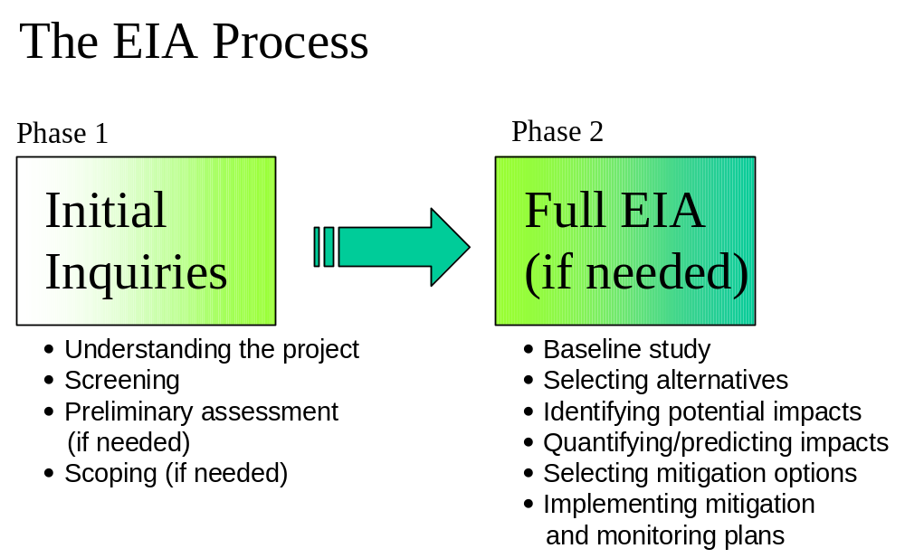
Each of these steps is outlined very briefly below. They are described in more detail in Section 2.

Initial inquiries: is a full EIA needed, and what should it cover?

Figure 1-2: Phase 1 of the EIA process
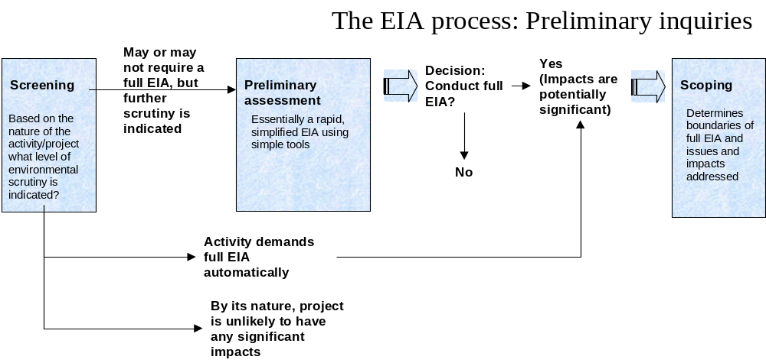
- Understanding the project. The EIA process begins by gathering information about the activity or project. A key task is characterizing the purpose and need for a project or activity. Purpose and need should be defined initially in terms of why the activity is being carried out—not how or by what means results are to be achieved.
For example, the overall objective or purpose may be improving water supply, not digging a well. Provision of wells may be only one of several means of achieving the objective; such as piping water by gravity from a nearby spring, or installing a diesel pumping system to bring water from a river. Preliminary environmental impact assessment can help decision-makers select among the most environmental sound and economical alternatives. Another example: the purpose of a program or project may be improving access to markets. Initial environmental analysis would consider the various alternative means to achieving the objective, such as building a road or developing river transport.
After examining the purpose or need, the specifics of what the project intends to do must also be characterized—without knowing what the proposed action is, you cannot know how the action could alter the environment, much less what the impacts of those alterations would be.
- Screening is the first and simplest stage of environmental review. Based on the general characteristics of the project, screening determines the type of environmental review the project will require. The screening process results in one of three outcomes: (1) The nature of the project demands a full EIA; (2) By its nature, the project is unlikely to have any significant environmental impacts; (3) The project may or may not require a full EIA; further inquiry is indicated [or in the case of USAID, an Initial Environmental Examination (IEE) is required].
- Preliminary assessments are essentially a rapid, streamlined EIA using simplified or more generic tools. USAID’s IEE is a preliminary assessment. Preliminary assessments are conducted when the screening determines that further environmental examination of a project is indicated, but that the project does not automatically demand a full EIA. Preliminary assessments may require less than one person-week to more than one person-month of effort, depending on the need for background studies and site surveys. They can involve the use of many of the simpler methods, such as checklists and matrices, often used in full environmental impact assessments. The preliminary assessment may be sufficient itself, or it may indicate that a full EIA is needed.
- Scoping. Once a decision to conduct a full EIA is made, the scoping process is initiated to determine the key boundaries, issues, and impacts (e.g. time scale, geographical scale, budget, project alternatives, affected environment, significant impacts) that the assessment should address. Scoping also normally includes the selection of interdisciplinary expertise needed for the EIA, and the development of Terms of Reference for each of the individual team members.

The EIA itself
Most participants in this course will be involved in screening (required in all EIA processes) and preliminary assessments. Fewer will be involved in full-scale EIAs. However, an understanding of the full EIA process is important—particularly because preliminary assessments are essentially streamlined EIAs.
- Conduct a baseline study. A baseline study attempts to establish environmental outcomes in the absence of the project.
- Select alternatives: EIAs should compare the environmental impacts of three categories of actions: a) the proposed project under consideration; b) the no-action alternative; c) and other alternatives to the proposed project. (In most cases, legal requirements indicate that all three must be considered.) Alternatives are different means of meeting the general purpose and need of a proposed action, project, or program.
- Identify Potential Impacts: Identifying the potential impacts of a project combines science and art. A wide range of scientific tools and methods—from simple to complex—are available. However, the application of tools is subject to limitations—inadequate data, complex relationships, and limited time and resources. The art lies in knowing when to apply each tool and how to make important assumptions in the absence of complete information. The simplest and most commonly used tools are checklists, matrices, map overlays, and network analyses, which are primarily used for impact identification. Other more sophisticated tools can be employed, such as geographic information systems. Knowledgeable local experts, experienced judgment, and simple logical reasoning all help to fill data gaps and ensure that the tools are applied in a sound manner.
- Predict Potential Impacts: Once impacts are identified, the next step is to predict the extent of the changes in environmental conditions that are caused by the proposed action. To do so requires an understanding of the important cause-and-effect relationships.
- Determine Significance of Impacts. Significance of a predicted impact depends upon its context and intensity. Significance varies with the setting or context. For example, a new or rehabilitated road in an urban area could be far less significant than the same road in a remote or wilderness setting.
- Compare and Evaluate Alternatives: Once the level of potential impacts has been predicted, you will need to weigh and compare the various types of impacts in order to decide on the preferred alternative. Of necessity, this process involves value judgments and trade-offs.
- Identify Mitigation Options: Mitigation consists of activities designed to reduce the undesirable impacts of a proposed action on the affected environment.
- Prepare Mitigation and Monitoring Plans: The culmination of the EIA process should be the preparation, testing and implementation of practical mitigation and monitoring workplans. Doing so is essential if the full value of the EIA exercise is to be realized.

The EIA process and the Project Lifecycle
The environmental assessment process should begin early in the project planning stage. This will ensure that planning and decisions reflect environmental values, avoid unnecessary delays or procedural corrections later in the planning process, and minimize potential conflicts. In addition, design changes can be incorporated into the project planning to avoid or reduce environmental impacts identified by an EIA.
By contrast, if major project decisions are made and/or funding committed before the EIA occurs; then the EIA can have little influence on choices regarding project or activity design, siting, technology, scale, beneficiaries or the like. At worst, the environmental assessment may become simply an exercise to meet a requirement—not an appropriate way to achieve environmentally sustainable development.
As shown in Figure 1-3, EIA has a role in each phase of the project lifecycle—from initial concept to decommissioning. This includes:
- initial examination during a pre-feasibility phase;
- detailed assessment, if required based on an initial analysis;
- detailed mitigation plans as a follow-up to the initial examination or detailed assessment to accompany the design phase;
- monitoring (and adjustment as appropriate) of mitigation measures carried out, during construction and/or operation;
- re-assessment at decommissioning or abandonment of a project.
- Finally, when an organization carries out a large number of similar activities or projects, programmatic or generic environmental assessment may be appropriate. Such reviews lead to criteria for design and implementation, generic modifications, or adoption of required procedures for screening or assessing project or activity sites and/or their components.
Figure 1-3: the EIA process in relation to the project lifecycle.
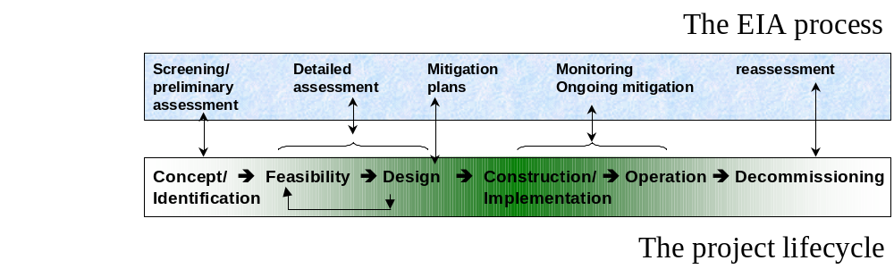

Which stakeholders are involved in an EIA?

Sponsors and institutions
The sponsor of an action (the proponent or the group or institution that proposes the action) is typically responsible for assessing its environmental impacts, at least in the initial stages. (This situation is not ideal as potential conflicts of interest can arise because the project sponsors are almost always biased in favor of the action.)
In some situations, a funding or lending agency (such as USAID, the World Bank, or sometimes even a mortgage lending bank) and/or a regulatory agency (such as a national or other level body) will have reviewing or even veto authority.
Other agencies of government or even international bodies can be concerned, although not necessarily have statutory responsibility. For example, a Wildlife Department may be concerned about activities or projects in the vicinity of a protected area, but have no control over how neighboring land is used or managed. Activities that affect habitat for migratory birds could attract the attention of other nations or of international groups concerned about birds, but they may have no direct means to preserve or manage those habitats.
In general, it is extremely useful to understand the concerns of a reviewing or funding/lending agency, to know the limits of jurisdiction and the authority of regulatory agencies, and to involve them at the earliest stages.

The public
Clearly, the concerns of populations directly or indirectly affected by a project need to be taken into account in the EIA process. One important means of doing so is through public participation. A proposed project or activity may affect various segments of a population in very different ways, and without a public participation component EIA planners may have difficulty envisioning these impacts. Impacts may be differentiated on the basis of:
- age, health or gender (e.g., old or young; healthy or infirm; male or female)
- wealth and occupation (e.g., rich or poor; farmer, pastoralist, transporter, businessman)
- location and use of resources (For example, consider the differences in impacts of constructing a dam on (1) downstream users of a river versus the upstream users; (2) dryland farmers versus those using irrigation, if the dam effects river flows or water quality; or (3) herders versus industries or urban areas withdrawing water.)
See Sidebar 1.D on public participation.

Resources required for preparing an EIA
The minimum resources needed to perform EIAs that can successfully shape major projects are described in UNEP (1988, p.15). These include:
- Qualified multi-disciplinary staff;
- Technical guidelines, agreed with the competent authority;
- Information about the environment;
- Analytical capabilities;
- Administrative resources;
- Institutional arrangements; and
- Review, monitoring, and enforcement powers.
Other than qualified staff, the most essential resources are time and money. The following are some estimates from various sources:
- Generic, preliminary assessments may take from 2 to 10 weeks (UNEP, 1988).
- The World Bank cites the rule of thumb that EA preparation cost rarely exceeds one percent of the total capital cost of the project and is frequently less than that.
- The cost of implementing mitigation measures can range from 0 to 10 percent of total project cost, with 3 to 5 percent being common. These estimates are without taking into account possible cost savings that result from implementing EIA recommendations. Effective EIA mitigation and monitoring can reduce or avoid the costs of environmental impacts or allow environmental objectives to be met in a more cost-effective manner. For example, project-induced epidemics of malaria or schistosomiasis may cost millions (US$) to bring under control, compared to the relatively minor costs of preventing them. (World Bank, 1991). And the costs in human suffering may not be accounted for at all.

1.E Examples of EIA resource requirements
World Bank EIAs. The time required to prepare an EIA, and the resulting cost, vary with the type, size and complexity of the project; the characteristics of its physical, sociocultural and institutional settings; and the amount and quality of environmental data already available. EIAs need as much time as the feasibility study, of which EIA is essentially a part. Therefore, EIAs can take from less than six months to more than 18 months to complete, but many require about 12 months. EIAs conducted according to Bank procedures do not delay projects; on the contrary, in many cases, they have shortened the total time from identification to operation, by revealing promptly environmental issues that might have halted work altogether, had they emerged at a later stage. Whether or not a particular EIA actually delays a project depends largely on how well it is coordinated with feasibility studies and other preparation activities (from World Bank, 1991).
USAID EAs. In comparison, the USAID EA can be a relatively modest analysis requiring a team of two or three people from three weeks to four months to complete, once the scoping sessions are completed. The scoping process, it should be noted, can be rather time consuming.
Requests for USAID categorical exclusions typically require less than a day to prepare.
USAID Initial Environmental Examinations. Simple IEEs typically can be done in a few days, depending on the characteristics of the proposed activity and whether a field visit is necessary. IEEs of a complex nature can take several person-weeks or, sometimes, months to prepare. The IEEs for projects with multiple components, covering a wide geographic area or affecting many aspects of the environment may require weeks of staff time or outside consultant expertise and may require specialized interdisciplinary expertise from others. Consultation and/or coordination is typically needed with country officials, NGO representatives, the USAID country mission, regional offices, Washington or other donors and most likely with some combination of these.

- Generically, the length of time for standard EIA ranges from 3 months to 2 years. The cost is nearly always less than 1 percent of the cost of a major development project, a figure cited frequently in the literature (UNEP, 1988).

Expertise required
for conducting an EA
EAs require interdisciplinary analysis and are therefore prepared by teams: members work together in the field. The disciplines listed below are generally represented on the core team for any EA
- team leader/project manager—often a planner, social or natural scientist, or environmental engineer with experience in preparing several and/or similar EAs. This individual must have the management skills and experience to provide overall guidance and integrate the findings of individual disciplines;
- ecologist or biologist, with aquatic, marine or terrestrial specializations, as appropriate;
- sociologist/anthropologist, with experience with communities similar to that of the project;
- geographer or geologist/hydrologist/soils scientist.
If the project is in the agricultural sector, an agronomist, land-use specialist, forest scientist, or fisheries biologist, as appropriate, should be included in the core team. For industrial, energy or transport projects, an engineer with the corresponding expertise (such as in pollution control or road construction) will be needed (World Bank, 1991).
Economic expertise can also be particularly useful in assessing alternatives to proposed actions and mitigation strategies.
Role of outside consultants. For USAID and USAID partners, EAs are usually carried out by teams of outside consultants, while IEEs have been conducted by internal staff. EA teams may be strengthened with qualified local expertise and may also benefit from participation of the regional environmental staff (Hecht, 1991). World Bank experience is similar. Although there are countries where government agencies themselves are capable of preparing EAs, the usual method is for the borrower to obtain specialist consultants, just as they often do for feasibility studies.
Even when institutions and decision-makers rely on outside EIA consultants, it is important that the organization’s staff be intimately involved in the environmental review and assessment process, since they ultimately have the responsibility for implementing the resulting recommendations and mitigation and monitoring plans.
Sources of EIA expertise. EIA specialists can be retained from a variety of sources.
- Large international environmental consulting firms have many of the necessary disciplines on staff or in subconsultant arrangements, and can form and manage teams for any EIA.
- There are also smaller firms that specialize in EA and manage EIAs. They are more likely to need subconsultants to fill out EIA teams.
- The expertise of local consulting firms varies from country to country. Frequently a local firm will be able to provide experts (e.g., from local universities or institutions) to participate in an EIA as a core team member or as a specialist. It is less common, at present, to find local firms with experience and capability to carry out EIAs on their own. Where such firms do exist, they should be seriously considered for EIA projects. Local firms should be participants in EIAs being managed by international firms. This provides the local staff with on-the-job training and provides the international staff with essential local knowledge, and experience.
- Other sources of experts include research institutions (e.g., marine institutes, tropical medicine research centers, national research institutions), colleges and universities, academies of science and technology and government agencies (loans and exchanges among countries may be possible), and NGOs.

Differing EIA requirements
This section provides a generic overview of the EIA process. However, as the discussion of resource needs above implied, EIA requirements differ between institutions. Differences in EIA policies among bilateral and multilateral agencies can unfortunately confront host governments and project collaborators with a bewildering array of procedures and requirements, particularly where several funders are involved in a single project (Campbell, 1993).
This briefing is focused on USAID EIA requirements. The overview of EIA it provides is generally applicable—but the specific training it provides on institutional procedures is applicable only to USAID projects.

Particular challenges of EIA in developing countries
Two primary difficulties confront the preparation of EIA documents in developing countries:
- Data availability. It is not an exaggeration to state that environment-related data may be virtually non-existent in many developing countries. Such data were initially not available in industrialized countries either. While governments are expected to collect and make available such information, there are typically major costs involved in doing so. Thus, while data availability remains a problem in the industrialized world, in developing countries it is one of the greatest hindrances to environmental planning.
- Trained personnel. Environmental expertise in developing countries is typically in very short supply and, within government agencies, often underpaid. Specialists may find themselves pulled in several different directions by multiple demands from the organizations they serve and by donor and private sector interests. Increasing developing country capacity in EIA can help to partially overcome these difficulties. At the same time, local EIA capacity development can improve the quality of EIAs by making greater use of expertise with local knowledge and understanding.
Too often developing country EIAs have been carried out primarily by external consultants with little understanding of local conditions. Skills are required at all levels of environmental planning – field research, analysis of information, reviewing EIA reports, etc. While it is true that environmental problems often exhibit common characteristics, many environmental problems faced by the developing world are fundamentally different from those faced by developed nations. As a result, local expertise can be of critical importance.
NGOs and donors need to be aware of the importance of engaging local expertise in EIA exercises, both as a means of building local capacity, as well as providing important knowledge. This is particularly true of social assessment and risk analysis, where perceptions may differ greatly among groups. In this regard, regional cooperation in EIA can be expected to be increasingly important among countries with similar economic, social, and cultural backgrounds.
EIAs in developing countries are becoming increasingly sophisticated—particularly as experience is gained over time. Using in-country expertise creates greater ownership of the resulting recommendations and mitigation measures than occurs when studies are carried out exclusively by external consultants.

The EIA process in more detail

In this section, we discuss the EIA process in greater detail.

Introduction
As stated in Section 1.5, the EIA process is divided into two phases—initial inquiries, and the EIA itself. This section provides more detail on each phase. Tools and methods which may be employed within each phase are the subject of subsequent sections.
Figure 2-4: Summary of the EIA process
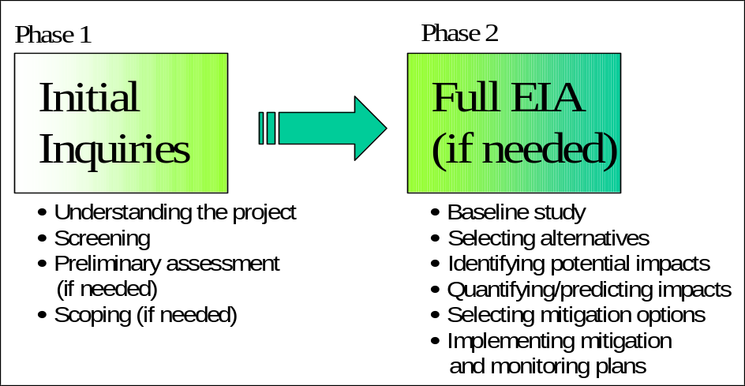

Phase 1: Initial inquiries
Phase 1 of the EIA process consists of gathering information on the project, screening the project—and, if indicated, a preliminary assessment and a scoping exercise.
Figure 2-5: Phase 1 of the EIA process
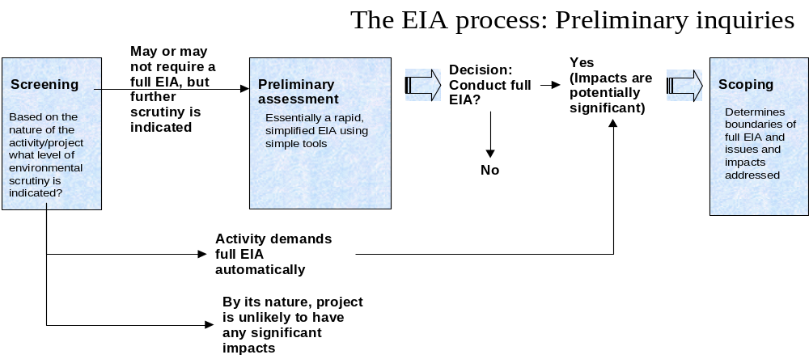

Understanding the project
The EIA process begins by gathering information about the activity, project or program. This step has two components:
- Characterizing the purpose and need for the activity, project or program. The purpose and need should be defined in terms of why the activity is being carried out—not how or by what means results are to be achieved. Table 2-1 provides examples of the differences between purpose/need and means.
Table 2-1: The difference between purpose and means
Purpose/need/overall objective of an activity, project or program | Means or specific actions taken to achieve overall objective
Improving water supply | Digging a well
Improving access to markets | Building a road
Improved income or agricultural production | Fertilizer introduction or promotion

The description of purpose and need should include: the intended beneficiaries, the results to be expected, and the rationale for how the activity is expected to achieve the results.
Describing the purpose or need for the project in this fundamental way is vital to understanding the alternatives that may be available. For example, water transport or air access can sometimes be viable alternatives to a road. Considering meaningful alternatives is a central part of the EIA process (below).
- Identify the project components. What the project intends to do must also be characterized—that is, the means which are to be used to achieve its objective or purpose. Without knowing what the proposed action is, you cannot know how the action could alter the environment, much less what the impacts of those alterations would be.
To understand the components of the project, communicate with program developers, project designers, engineers, and whoever else is involved in formulating the action and, if possible, visit a similar activity or project. By knowing what the activity or project components are specifically, you can determine what is or is not likely to be a problem. For example, in a national park, air or noise may not likely be a problem, but loss of habitat could be.
You should consider all the parts of a project. For example, reservoirs may require haul roads, intake structures on a river and pipelines to carry water to feed the reservoir, or borrow areas at some distance from the site. Road construction, including rehabilitation, may require borrow areas, quarry sites or temporary detour roads. You should define not just the action, but all subsidiary components.

Screening
Screening is the first and simplest stage of considering the environmental impacts of an activity. Based on the general characteristics of the project, screening determines the type of environmental review the project will require. The screening process results in one of three outcomes:
- The nature of the project demands a full EIA.
- By its nature, the project is unlikely to have any significant environmental impacts.
- The project may or may not require a full EIA; further inquiry is indicated.
Screening is an element of any EIA process and is generally undertaken at the stage of project identification. Most environmental impact assessment processes involve initial screening protocols to evaluate the level of likely impacts and the extent of environmental review needed. In the case of both USAID and the World Bank, there are categories of activities, which are either likely or unlikely to have a significant effect on the environment, and thus distinguish the level of environmental review needed. Table 2-2 at the end of this section compares these two sets of categories.
Environmental screening can involve some initial and limited efforts to assess the nature and significance of likely impacts. Under some definitions of screening, this step includes using simple impact identification methods, such as guided questions or checklists, to help redesign projects at an early stage. In other cases, these efforts are part of a preliminary assessment—e.g., USAID’s “Initial Environmental Examination”—which may or not be required depending on a simple screening protocol.

Preliminary assessment
Preliminary assessments are essentially rapid, streamlined EIAs using simplified or more generic tools. Preliminary assessments are conducted when the screening determines that further environmental scrutiny of a project is indicated, but that the project does not automatically demand a full EIA.
Preliminary assessments may require less than one person-week to more than one person-month of effort, depending on the need for background studies and site surveys. They can involve the use of many of the simpler methods, such as checklists and matrices, often used in full environmental impact assessments. The preliminary assessment may be sufficient itself, or it may indicate that a full EIA is needed.
An example of a preliminary assessment is the USAID Initial Environmental Examination (IEE). Based on the IEE, a decision on whether to conduct a full EA is usually made or deferred.
Note that in practice, preliminary assessments and environmental screening procedures are tightly linked and may not be distinct from each other.

Scoping
Once a decision to conduct an EIA is made, the scoping process is initiated to determine the key issues and choices of alternatives to be examined in the full EIA. Issues include, but are not limited to:
- time scale,
- geographical scale,
- budget,
- affected environment, and
- significant impacts.
2.A: The origins of scoping
In the U.S., scoping originated in response to early applications of NEPA by federal agencies. In some early environmental impact studies, great lengths were made to study every conceivable impact, regardless of its significance, and consequently enormous EIAs were submitted in which critical issues were obscured by the volume of details. Other environmental impact studies went to the opposite extreme, presenting too little information and analysis to be of use in the environmental decision-making process. To remedy these problems, the existing EIA regulations were supplemented to include a requirement for all agencies to engage in scoping at the beginning of the EIA process (Environmental Law Institute, 1991).

The scoping process is intended to assure that: (1) real problems are identified early and studied properly; (2) that issues which are not significant or which have been treated in prior EIAs are eliminated from detailed study; and (3) that the final EIA report is balanced and thorough.
Scoping is an early, open part of the EIA process. It is typically carried out in a meeting or series of meetings involving the project proponent, local experts, the public, and the responsible government agencies. The structure of the meetings may vary depending on the nature and complexity of the proposed action and on the number of interested participants:
- Small-scale scoping meetings might be conducted like business conferences, with participants contributing in informal discussions of the issues.
- Large-scale scoping meetings might require a more formal atmosphere, like that of a public hearing, where interested parties are afforded the opportunity to present testimony.
- Other types of scoping meetings could include "workshops," with participants in small work groups exploring different alternatives and designs.
In defining the boundaries of the EIA, scoping defines the interdisciplinary expertise needed for the EIA. As part of the scoping exercise, Terms of Reference are typically developed for each of the individual team members. As is the case with all procedural and analytical stages of the EIA process, documentation of the scoping process should be systematic and thorough.

Phase 2: the EIA itself

Conduct a baseline study
A baseline study attempts to establish what environmental conditions will be in the absence of the project. A baseline study is essential for two reasons:
- The activity acts on and within the environment which the baseline study seeks to characterize. Without the baseline study, environmental impacts cannot be predicted.
- Even if impacts could be predicted, they only have meaning when compared to the state of the environment in the absence of the project, and under alternatives to the project. In both cases, a baseline study is required.
Unfortunately, often in the rush to meet funding obligation deadlines, programs and projects may be designed and implemented with inadequate baseline information. As a result, many environmental assessments are carried out and interventions implemented with insufficient commitments of time and resources for collection and analysis of baseline data.
Three general principles should guide baseline studies:
- Concentrate on relevant and important factors. Historically, environmental specialists have wasted considerable effort on gathering information and performing analyses not directly relevant to assessing the nature and degree of environmental impacts. Early baseline studies compiled lists of things in the affected environment, and told little about ecosystem function and response. Today, baseline studies are more focused on the ecosystem properties most sensitive to disturbance.
- Establish the appropriate geographic areas in which the environment is to be “baselined.” This requires understanding where impacts arising from the project are likely to occur. For this, you must consider the phases of the activity from planning through decommissioning and determine the geographic areas likely to be affected by each phase. Areas to consider include: the site itself, the immediate site vicinity or neighborhood, the watershed, the airshed, the general area or region (transport routes, off-site construction quarries, disposal areas, etc.), the specific administrative jurisdictions, and areas with economic and trade linkages to the project site. (The last category is particularly relevant to socioeconomic or fiscal impacts),

2.B Major elements of the environment characterized in baseline studies
Geology—geological provinces, bedrock formations, history of geological stability or instability
Topography—general topography of region, specific topography of project area
Soils—soils mapping, soil series properties, constraints to development
Groundwater Resources—nature of water-bearing formations, recharge rates, sustainable safe yields, locations and depths of existing wells, quality
Surface Water Resources—drainage basins and sub-basins, named and unnamed water bodies and watercourses, regulatory classification of water bodies, flow regimes, water quality data and evaluation, identification of existing permitted discharges to surface waters
Terrestrial Communities—spatial arrangement of vegetative community types, vegetative species-abundance listings, wildlife species-abundance listings, records of threatened and endangered plant and animal species
Aquatic Communities—nature of aquatic habitats, species-abundance listings for aquatic macro-invertebrate and fish communities, ecological indexing of community data
Environmentally Sensitive Areas—identification of wetlands, floodplains, steep slopes, stands of mature vegetation, aquifer recharge areas, areas of high water table, areas of rock outcrop, prime agricultural lands, and mines. Identification of existing protected areas (e.g., national parks and forests).
Air Quality—regional quality and trends, data from local monitoring stations, reported exceedances of standards
Sound Levels—existing sound levels, sources of sound
Land Use—existing patterns of land use in region, regional planning for future use, zoning
Demography—censused or estimated population, recent trends and projections for future population
Socioeconomics—economic and social structure of communities, tax rates, characteristic types of development
Infrastructural Services—nature and status of human services such as police and fire protection, hospitals, schools, utilities, sewage, water supply, solid waste disposal
Transportation—layout and function of existing roadways, railways, airports; existing and projected capacities and demands
Cultural Resources—location and characterization of identified cultural resources (archaeological, historical, cultural, landmark), potential for unidentified resources to be present in project area
Project Economics—comparative analysis of proposed alternatives with present worth cost-effective criteria, cost/benefit criteria, or other methods
Note that different project alternatives can affect different geographic areas. Avoid the common mistake of concentrating too much on the site of the activity itself and not on the surroundings.
- Provide a level of descriptive detail that is sufficient to indicate the nature of the natural and human resources that are potentially affected by the proposed action. The level of detail will vary with the nature of the proposed action and affected resources, as well as with the availability of data and the priority concerns identified in the scoping process.
Note that in some instances, the establishment of baseline data may require that data survey work be expanded, refined or extended through seasons or years in order to establish reliable environmental information over time.
Sidebar 2.B describes the major elements of the environment that may be characterized in a baseline study.

Identify alternatives to be studied
EIAs should consider the impacts of three alternatives: a) the proposed activity, project or program under consideration; b) the no-action alternative; c) and other alternatives to the proposed activity that fulfill the general objective or need. In most cases, legal requirements indicate that all three must be considered.
Identifying and describing feasible alternatives should be carried out as soon as possible after the purpose and need are established; in this way, project planning does not bias the assessment toward one alternative or another.
Alternatives should offer legitimate and substantive choices. Ideally, the alternatives evaluated should provide decision-makers with different geographical locations for the action and with different technical or planning solutions for meeting the same need or objective.

Identify potential impacts
Any or all of the elements of the environment characterized in the baseline study may be affected by the proposed activity. The EIA seeks to identify what the impacts may be, and then to predict or quantify them.
Identifying the potential impacts of an activity and its alternatives combines science and art. A wide range of scientific tools and methods—from simple to complex—are available. However, the application of tools is subject to limitations—inadequate data, complex relationships, and limited time and resources. The art lies in knowing when to apply each tool and how to make important assumptions in the absence of complete information.
The simplest and most commonly used tools are checklists, matrices, map overlays, and network analyses, Other more sophisticated tools can be employed, such as computer-based geographic information systems. Knowledgeable local experts, experienced judgment, and simple logical reasoning all help to fill data gaps and ensure that the tools are applied in a sound manner.
Sidebar 2.C describes the types of potential impacts to be considered in this stage of the EIA process. Again, these impacts may affect any of the environmental elements characterized in the baseline study.

Predict potential impacts
Once potential impacts are identified, the next step is to quantify these impacts—that is, to predict the extent of the changes in environmental conditions that would be caused by the proposed action and its alternatives. To do so requires an understanding of the important cause-and-effect relationships.
2.C: Classes of impacts
- Direct (Primary) vs. Indirect (Secondary) Impacts. Direct impacts are those effects that are generally associated with the construction, operation, or maintenance of a facility or activity. They are generally obvious and quantifiable.
Indirect impacts are induced changes in the environment, population, economic growth and land use.
- Examples of indirect impacts include: strip settlement associated with new roads, waterborne disease associated with abandon construction borrow pits, or siltation of rivers and streams caused by construction activity.
- Short-Term (Temporary) vs. Long-Term (Permanent) Impacts. Impacts can be short-term or long-term depending upon the persistence or duration of the impacts. The duration of impacts may have a lot to do with the project phase in which they occur: pre-operational (e.g., construction), operational, or post-operational (e.g., after project completion or decommissioning).
- Impacts can also occur in anticipation of a project. The threat of an activity or project considered undesirable can lead to loss of land value, making it difficult to transfer nearby properties, even before the project occurs. Likewise the promise of an action considered desirable may induce people to move to the location, in hopes that they will become project beneficiaries. Concerns about relocation can be more intense before a move than the actual relocation. It is a common pitfall to ignore those impacts occurring in the planning and assessment phase or those that occur after the project has served its useful life.
- Positive (Beneficial) and Negative (Adverse) Impacts. Although the term "environmental impact" has come to be interpreted in the negative sense, many actions have significant positive effects that should be clearly defined and discussed. This is particularly appropriate for redevelopment or remedial actions whose specific purpose and need is to remedy any undesirable condition.
- Cumulative Impacts. Cumulative impacts are those environmental impacts that result from the incremental impact of the proposed action on a common resource when added to other past, present, and reasonably foreseeable future actions. Circumstances generating cumulative impacts could include: water quality impacts from an effluent discharge that is combined with other point source discharges or from non-point source runoff; or loss and/or fragmentation of environmentally sensitive habitats (forests, wetlands, farmlands) resulting from several separate development projects. The assessment of cumulative impacts is difficult, in part due to the speculative nature of the possible future actions, and in part due to the complex interactions that need to be evaluated when considering collective effects. Water and air quality modeling provide a means to study effects of cumulative impacts.
Environmental impacts cannot be described in one word. Each impact has a number of dimensions which together create a full description of the impact. Typical descriptors or dimensions are depicted in sidebar 2.D. If possible, a forecast or prediction should be made for each dimension.
In general, there are two approaches that are commonly used to predict ultimate impacts:
- Quantitative analyses relies on simulation models, such as air quality or water quality models, that represent the linkages between elements of ecosystems or other environmental components in mathematical terms.
Simulation modeling tends to be complex, expensive, and data-intensive. Its use may be limited due to data and financial constraints common to most developing countries.
Not all quantitative analyses need to rely on models, however. The number of people affected, such as those relocated or subject to some describable change in the environment, can be counted; the acres of habitat disturbed can be measured; the per capita amount of sewage or solid waste generated can be estimated; the loss of an economic resource and its income value can be calculated.
- Qualitative analyses rely on professional judgment or intuitive reasoning to predict cause and affect relationships and ultimate impacts. Often, these types of predictions are most appropriate given resource constraints.
One straightforward way to systematically consider impacts qualitatively but systematically is to think about linkages among impacts. Road-related wildlife deaths, for example, are a function of projected traffic volumes and speeds. Traffic volume and speed, in turn, depend upon the type and kind of road and the population in an area; the level and significance of impact would depend upon the types of wildlife in the area and whether migration or reproductive patterns would be severely affected.

Determine significance of impacts
2.D: Characteristics of environmental impacts
Magnitude: the absolute or relative change in the size or value of an environmental feature. Uncertainty is likely in forecasting the magnitude of change, and some upper and lower estimates may need to be given.
Direction: the impact will represent a beneficial or negative change. It is therefore important to know the direction of the impact as beneficial impacts are welcome. Negative impacts are cause for most concern.
Extent: the area affected by the impact -- e.g., in hectares of productive agricultural land or kilometers of river. A distinction here between on-site and off-site impacts is often useful.
Duration: the time period over which the impact will be felt. Some impacts may be very short term (i.e., during construction), some may occur over a number of years, and some may be permanent. It is often desirable to specify duration in terms of short-term (i.e., 1 year or less), medium-term (i.e., 1 to 10 years), and long-term (i.e., more than 10 years).
Frequency: refers to the return period for impacts which will recur over and over again—e.g. seasonal water quality problems. Return period can often be specified by interval—e.g. annually or less, 1 to 10 years, 10 to 100 years.
Reversibility: refers to the permanence of the impact. Several distinctions are possible here. Impacts may be reversible by natural means at natural rates, reversible by various forms of human intervention at reasonable costs, or be, for all practical purposes, irreversible. Irreversible impacts are likely to be more severe as this assumes permanent damage to the environment.
Likelihood of Occurrence: refers to the possibility of a particular impact occurring as forecast. Here, an estimate is made about how certain the impact prediction is, given the limitations of environmental science. Again, establishing categories of analysis such as "definite," "probable" and "possible" may come in useful if they are well-defined.
(adapted from Takawira, 1995):
The significance of a predicted impact depends upon its context and intensity.
Significance varies with the setting or context. For example, the loss of one hectare of park in an urban setting may be more significant than the same quantitative loss in a more rural setting—unless of course that hectare is habitat for an endangered species (or belongs to you!). A new or rehabilitated road in an urban area could be far less significant than the same road in a remote or wilderness setting.
The intensity of an impact depends upon the degree to which an action:
- affects public health, safety, or livelihood;
- affects unique characteristics of an area (culturally or historically important resources, park lands, prime farmlands, wetlands, wild and scenic rivers, ecologically critical areas);
- is likely to be highly controversial;
- is highly uncertain or involves unique or unknown risks;
- establishes a precedent; or
- adversely affects endangered or threatened species or habitat.
Thus, determining "significance" involves a judgment. This judgment is influenced by applicable national or international laws protecting the environment, by regulations of the funding institution, and also by societal perceptions about what is important.

Compare and evaluate alternatives
Once the level of potential impacts has been predicted, you will need to weigh and compare the various types of impacts in order to decide on the preferred alternative. Of necessity, this process involves value judgments and trade-offs between environmental and economic gains and losses. Therefore, the methods you use to make the comparisons should be as explicit and transparent as possible.
There are various systematic approaches that can help in this effort, such as environmental indices, cost-benefit analysis, hypothetical choice approaches, and multi-criteria analysis. However, all involve subjective and value-laden premises, since comparisons must be made between unlike things. Put another way, it is very difficult to compress information about attributes into a single monetary measure. For example, there is no objective criteria one can apply to compare the inherent value of an endangered species with the economic benefits of a hydroelectric dam.

Identify mitigation options; prepare mitigation and monitoring plans
Mitigation is the purposeful implementation of decisions or activities that are designed to reduce the undesirable impacts of a proposed action on the affected environment. Mitigation is a general concept that could include the following list of categories:
- Avoiding impacts altogether by not taking a particular action;
- Minimizing impacts by limiting the magnitude of the action;
- Rectifying impacts by repairing or restoring particular features of the affected environment;
- Reducing impacts over time by performing maintenance activities during the life of the action; and
- Compensating for impacts by providing additions to or substitutes for the environment affected by the action.
Note that the mitigation approaches above are arranged in order of their desirability. In other words, it is more desirable to avoid impacts than to rectify impacts after the fact or provide compensation for them (Environmental Law Institute, 1991).
The culmination of the EIA process should be the preparation, testing, and implementation of practicable mitigation and monitoring workplans. Mitigation and monitoring is the subject of Section 4.

Communicating findings: sample outlines
Communicating findings is an essential part of the EIA process. The purpose of the EIA process is to foster better decision-making. This demands both that the EIA process be technically sound and that findings be communicated clearly.
Different institutions (e.g., USAID, the World Bank) require their own particular formats for reports and statements that document the EIA process. Selected sample formats meeting World Bank and USAID requirements are presented in Annex 2.A.

Annex 2.A: Sample outlines of USAID and World Bank EIA documents

Indicative outline: USAID Initial Environmental Examination (IEE)
NOTE: The IEE is likely to be the most common type of EIA document prepared by Mission staff. The IEE is discussed in detail in the USAID Environmental Procedures Training Manual available from http://www.encapafrica.org.
PROGRAM/PROJECT DATA:
- Program/Activity:
- Organization Name, Country/Region:
The following narrative should be organized around the major activity sub-headings, if the activity categories are rather distinct, e.g., road construction, agricultural development, and irrigation works.. Treat each major activity under each section. Alternatively, one could organize by activity and then each major heading would cover the Sections 1 to 4. The summary in Section 5 is to cover all categories addressed, with an overview of the summaries at the end.
1.0 BACKGROUND AND ACTIVITY DESCRIPTION
- Describe why the activity is desired and appropriate, and outline the key activities proposed for funding. A current activity description should be provided and the purpose and scope of the IEE indicated (amendment, why needed, what it covers).
2.0 COUNTRY AND ENVIRONMENTAL INFORMATION
- This section is critical and should briefly assess the current physical environment that might be affected by the activity. Depending upon the activities proposed, this could include an examination of land use, geology, topography, soil, climate, groundwater resources, surface water resources, terrestrial communities, aquatic communities, environmentally sensitive areas (e.g., wetlands or protected species), agricultural cropping patterns and practices, infrastructure and transport services, air quality, demography (including population trends/projections), cultural resources, and the social and economic characteristics of the target communities.
The information obtained through this process should serve as an environmental baseline for future environmental monitoring and evaluation. Be selective in the country and environmental information you provide, as it should be specific to the activity being proposed and more information is not necessarily better.
Finally, indicate the status and applicability of host country, Mission, and proposing organization policies, programs and procedures in addressing natural resources, the environment, food security, and other related issues.
3.0 EVALUATION OF ACTIVITY/PROGRAM ISSUES WITH RESPECT TO ENVIRONMENTAL IMPACT POTENTIAL
- This section of the IEE is intended to define all potential environmental impacts of the activity or project (direct, indirect, beneficial, undesired, short-term, long-term, or cumulative).
4.0 RECOMMENDED MITIGATION ACTIONS (INCLUDING MONITORING AND EVALUATION)
- For each proposed activity or major component, recommend whether a specific intervention included in the activity should receive a categorical exclusion, negative determination (with or without conditions), positive determination, etc., as well as cite which sections of Reg. 216 support the requested determinations.
Recommend what is to be done to avoid, minimize, eliminate or compensate for environmental impacts. For activities where there are expected environmental consequences, appropriate environmental monitoring and impact indicators should be incorporated in the activity’s monitoring and evaluation plan.
5.0 SUMMARY OF FINDINGS
- This should summarize the proposed environmental determinations and recommendations.

Indicative outline of a USAID Environmental Assessment Report
Below is a typical outline for Environmental Assessment reports submitted to the USAID. It is based on communications from USAID environmental advisors. (See 22 CFR Part 216.6 for a more complete description of EA contents).
1. Summary: This section stresses major conclusions, areas of controversy, and issues to be resolved.
2. Introduction:
a. Description of proposed action.
b. Purpose of project.
c. Results of the scoping exercise
3. Alternatives: This section discusses which alternatives were chosen and why; contrasts impacts among alternatives, and identifies preferred alternative(s) and appropriate mitigation measures. It draws upon the analyses documented in Chapter 5.
a. Environmental impacts of proposed action
b. Environmental impacts of no action
c. Environmental impacts of alternative 1...
4. Affected Environment: Essentially this section is the baseline study. It succinctly describes the affected environment, using data and analyses commensurate with the significance of the impacts.
5. Environmental Consequences: This section presents the basis for section 3 above. It can be organized according to technical discipline (e.g., ecological impacts, land use impacts, water quality impacts, etc.) or by the nature of the impacts (long-term, short-term, irreversible, etc.) Organizing by technical discipline can be efficient, since specialists can be assigned to write appropriate sections.
6. List of Preparers
7. Appendices

Indicative outline of a World Bank project-specific EA report
Below is a typical outline for a project-specific environmental assessment report submitted to the World Bank. It is adapted from World Bank, 1991, Annexes A1 and 1-3 (note: Bank-specific language and requirements have been deleted). The Bank requires that full EA reports should be concise and should focus on the significant environmental issues. The report's level of detail and sophistication should be commensurate with the potential impacts. The following items should be included in the report:
(a) Executive Summary. Concise discussion of significant findings and recommended actions.
(b) Policy, Legal, and Administrative Framework. Discussion of the policy, legal, and administrative framework within which the EA is prepared. The environmental requirements of any co-financiers should be explained.
(c) Project description. Concise description of the project's geographic, ecological, social, and temporal context, including any off-site investments that may be required by the project (e.g., dedicated pipelines, access roads, power plants, water supply, housing, and raw material and product storage facilities).
(d) Baseline Data. Assessment of the dimensions of the study area and description of relevant physical, biological, and socioeconomic conditions, including any changes anticipated before the project commences. Current and proposed development activities within the project area (but not directly connected to the project) should also be taken into account.
(e) Environmental Impacts. Identification and assessment of the beneficial and adverse impacts likely to result from the proposed project. Mitigation measures, and any residual negative impacts that cannot be mitigated, should be identified. Opportunities for environmental enhancement should be explored. The extent and quality of available data, key data gaps, and uncertainties associated with predictions should be identified/estimated. Topics that do not require further attention should be specified.
(f) Analysis of Alternatives. Systematic comparison of the proposed investment design, site, technology, and operational alternatives in terms of their potential environmental impacts; capital and recurrent costs; suitability under local conditions; and institutional, training, and monitoring requirements. For each of the alternatives, the environmental costs and benefits should be quantified to the extent possible, and economic values should be attached where feasible. The basis for the selection of the alternative proposed for the project design must be provided.
(g) Mitigation Plan. Identification of feasible and cost-effective measures that may reduce potentially significant adverse environmental impacts to acceptable levels, and estimation of the potential environmental impacts; capital and recurrent costs; and institutional, training, and monitoring requirements of those measures. The plan (sometimes known as an “action plan,” or “environmental mitigation or management plan”) should provide details on proposed work programs and schedules. Such details help ensure that the proposed environmental actions are in phase with engineering and other project activities throughout implementation. The plan should consider compensatory measures if mitigation measures are not feasible or cost-effective.
(h) Environmental Management and Training. Assessment of the existence, role, and capability of environmental units on-site, or at the agency and ministry level. Based on these findings, recommendations should be made concerning the establishment and/or expansion of such units, and the training of staff, to the point that EA recommendations can be implemented.
(i) Environmental Monitoring Plan. Specification of the type of monitoring, who would do it, how much it would cost, and what other inputs (e.g., training) are necessary.
(j) Appendices
- List of EA Preparers--individuals and organizations.
- (
- ii) References -- written materials used in study preparation. This list is especially important given the large amount of unpublished documentation often used.
- Record of Interagency/Forum/Consultation Meetings -including lists of both invitees and attendees. The record of consultations for obtaining the informed views of the affected people and local NGOs should be included. The record should specify any means other than consultations that were used to obtain the views of affected groups and local NGOs.

Indicative outline for a USAID Scoping Statement
Below is a typical outline for a scoping statement submitted to USAID. (See 22 CFR §216.3(a)(4) for more detail.)
- Preface: The statement can begin with an overview of Reg. 216.
- General Project Description
- Environmental Assessment Issues
  - Significant Issues: This section lays out the scope and significance of issues to be analyzed in the Environmental Assessment or Impact Statement. Significant issues are numbered, and their significance for the environment and natural resources is described, including direct and indirect effects of the project on the environment. Following are examples of the types of significant issues that have emerged in scoping activities: accelerated erosion; pollution of groundwater; species and habitat loss; disease transmission; etc.
  - Issues That Are Not Significant: These issues are also numbered, with a brief presentation of why they will not have significant effect on the environment.
  - Environmental Assessment Preparation: This section suggests the timing of the preparation of environmental analyses, variations required in the format of the Environmental Assessment, and the tentative planning and decision-making schedule.
  - Conduct of Analysis and Disciplines Participating in the EA or EIS.
- Identification of the Participants in the Scoping Session

Annex 2.B: Screening criteria

Table 2-2: USAID vs. World Bank screening categories
USAID Categories | World Bank Categories
Activities generally requiring a full EA. (Classes of Activities With Environmental Impacts, 22 CFR Part 216.2(d)(1))  - river basin development  - irrigation and water management  - agricultural land leveling  - drainage projects  - large scale agricultural mechanization  - new lands development  - resettlement projects  - penetration road building or road improvement projects  - power plans  - industrial plants  - potable water and sewerage projects, other than small-scale  - use of pesticides | Category A: Full EA required. The projects or components included in this list are likely to have adverse impacts that normally warrant classification in Category A.  - dams and reservoirs  - forestry and production projects  - industrial plants (large-scale)  - irrigation, drainage and flood control (large-scale)  - land clearance and leveling  - mineral development (including oil and gas)  - port and harbor development  - reclamation and new land development  - resettlement and new land development  - river basin development  - thermal and hydropower development; and  - manufacture, transportation and use of pesticides and other hazardous and/or toxic materials.
Classes of projects not listed above or below that are subject to Initial Environmental Examinations to determine whether further analysis (EA/EIS) is needed | A Full EA is not required, some environmental analysis is. The following projects and components may have environmental impacts for which more limited analysis is appropriate  - agro-industries  - electrical transmission  - aquaculture and mariculture  - irrigation and drainage (small-scale)  - renewable energy  - rural electrification  - tourism  - rural water supply and sanitation  - watershed projects  small-scale rehabilitation, maintenance and upgrading
Categorical Exclusion: IEE or EA generally not required (See Reg 216 for important exceptions)  - educational, technical assistance and training  - controlled experimentation  - studies, academic or research workshops  - projects in which USAID is a minor donor  - non-project-specific contributions to organizations  - institution building grants to U.S. institutions  - nutrition, health care, family planning services  - commodity import program assistance  - support for intermediate credit institutions for capitalization  - maternal or child feeding  - food for development programs  - matching and support grants to PVOs  - local capacity building for development planning  - the application of design criteria approved by USAID | Category C: No EA or other analysis required.  - education;  - family planning;  - health;  - nutrition;  - institution development;  - technical assistance; and  - most human resource projects.

Information requirements and tools for screening and preliminary assessment

In this section, we overview the types of information needed to conduct the screening and preliminary assessment steps of the EIA process. Some practical, basic tools and methods you use are also introduced.
Much of the material in this section was drawn from CCIC, 1994: Environmental Screening of NGO Development Projects.

Introduction
As described in the previous section, Phase 1 of the EIA process consists of:
- gathering information to acquire an understanding of the project;
- screening, in order to reach a decision regarding what further steps of the EIA process, if any, will be conducted;
- preliminary assessment, a rapid and streamlined version of a full EIA. Preliminary assessments are performed when screening indicates that further scrutiny is needed, but that a full EIA is not automatically required. Preliminary assessment produces a decision as to whether a full EIA should be undertaken;
- scoping, an exercise to define the bounds of the full EIA study, should one be needed.
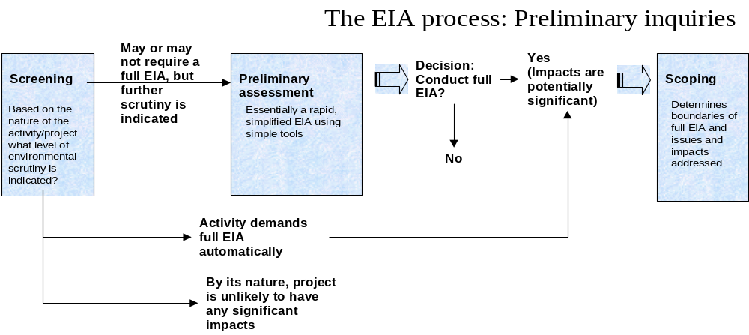

All EIA processes involve screening. Most USAID Mission staff will conduct preliminary assessments (for example, USAID IEEs) rather than full EIAs. This section thus focuses on (1) the types of information required to gain an understanding of the project and to screen it successfully; and (2) a set of relatively simple tools useful in the screening and preliminary assessment stages.

Information requirements
To screen a project for potential environmental impacts, certain information about the community and physical environment at the project site is needed. Some of this information will already have been collected to develop the project objectives. But additional data will likely be necessary to identify alternative methods of accomplishing the project objectives and to evaluate their respective impacts on the environment.

Environmental characteristics of the project site or area
The environmental data required will vary depending on the project or program. In general, however, the following data will be needed:
- General climatic information (e.g., annual rainfall patterns, longer-term flood and drought cycles, wind patterns);
3.A Sources of environmental data
At least some of the environmental data required for the screening and preliminary assessment will already exist. Sources of information include:
- Direct observation during a site visit;
- Local counterparts;
- Local villagers, farmers, and residents;
- Regional meteorological stations;
- Local government agencies, such as the Ministry of Agriculture or Forestry, or local agricultural extension workers;
- Airport;
- Local university or training centers;
- Local NGOs, consultants, and experts;
- National Conservation Strategy for Sustainable Development (IUCN);
- National Environmental Action Plan;
- National Report on Environment and Development prepared for the UNCED Rio 1992 conference;
- Tropical Forestry Action Plan;
- USAID Environmental Sector Assessment (sometimes referred to as Environmental Threats Assessment);
- USAID Biodiversity Assessments (in place or likely in process);
- GIS data bases (consult Ministry of Environment or Natural Resources or equivalent);
- FAO (which has supported international soils and water resource inventories in many areas).
- Land-use patterns (e.g., agricultural, urban, protected area);
- Resource use by the people (e.g., forestry, aquaculture, agriculture, fishing, natural grasslands for grazing);
- Type of habitats present (e.g., mangrove, forest, desert, grassland);
- Physical characteristics (e.g., soil type, topography, erosion potential, presence of streams, ground water characteristics);
- Biological characteristics (e.g., animal and plant species present and their significance, i.e., food source for the people, endangered species);
- Status of any protected areas (national or other parks, reserves, or other as defined by national or other laws) that could be affected by the action, including protected areas in any possible zone of impact (direct or indirect, upstream or downstream), description of location, characteristics, conditions; and
- Location and information about designated, classified, or gazetted forests (if not defined as a protected area per se under national or other law) as well as identification of any relatively undegraded forest, even if not classified or gazetted.

Economic and social data
Economic and social information useful for screening purposes usually includes:
- Crops and livestock raised, and associated agricultural practices (e.g., tillage and harvesting methods, pesticide and fertilizer use);
- Agriculture, rain-fed or irrigated;
- Local water sources and usage;
- Community resources (e.g., raw building materials, land ownership and distribution, work patterns, role of women);
3.B Sources of economic and social data
Much of the economic and social data required for the screening and preliminary assessment should be easily obtainable. Sources of information include:
- direct observation
- local counterparts
- local farmers and villagers
- local NGOs
These sources may supplement or replace official statistics, depending on the availability and relevance of official data.
- Local sanitation facilities and hygiene practices;
- Population size and demographics (e.g., principal diseases, health and family planning practices, sex/age distribution);
- Local religion, culture, and traditions;
- Literacy levels and educational training facilities; and
- Community organization, leadership, communication, and types of occupations.

Map-based information resources
Effort should be devoted to collecting and using available maps to identify and chart the location and movement of human and natural resources. Maps may display environmental or economic/social information, or they may combine the two categories. Map resources to look for include:
- Topographical and physical maps at the scale 1/10000 to 1/20000 provide information on: inhabited areas; major wind directions; waterways and water bodies; different types of vegetation cover; sensitive and fragile areas; protected forests; and, classified forests.
- Maps, plans and sketches of the proposed project or activity provide information on: land use around the selected site; areas disturbed during construction, and type of disturbance; existing or planned solid waste collecting systems, especially for urban projects; and, existing or planned liquid waste collection systems.

Tools for screening and preliminary assessment
Much EIA methodology literature, including the material included here, emphasizes impact identification, data assembly, prediction, and evaluation. These tasks are relevant both to full EIAs and screening/preliminary assessment.
Since most readers are unlikely to conduct full EIAs, this section does not discuss public participation, communication, or management techniques. These tasks are far more prominent in large-scale EIA efforts and are discussed extensively in a number of sources, including Cook and Donnelly-Roark (1994) and World Bank (1991, Volume 1). Additional background readings include Sadar (1994), Bisset (1987), and UNEP (1996).

Here we focus on the simpler EIA impact assessment tools and methods. Four are discussed here—checklists, matrices, overlays and networks. More resource-intensive and sophisticated techniques, such as simulation modeling, risk assessment and cost-benefit analysis, are briefly described in sidebar 3.E.

Checklists
Checklists are widely used in EIA processes to guide decision-making, especially during the prefeasibility and planning phases of the project lifecycle, when it is most critical to anticipate adverse impacts and to include mitigating measures in projects. Checklists are designed:
- to help identify significant negative impacts by providing the right questions to ask regarding the various project activities and the respective environmental components that may be affected. Checklists can be used to determine environmental impact thresholds, thus indicating whether a full-scale EIA is needed for a particular project;
- to provide a systematic approach to the environmental screening of development projects. A checklist forces the assessment to consider a standardized set of activities or effects for each proposed action, thus bringing uniformity to the assessment process;
- to indicate how and why certain project activities have environmental impacts which will allow planners to transfer those principles to the screening of projects not specifically addressed by the checklists;
- to assist in identifying appropriate mitigation measures to be incorporated into the project design; and,
- to increase environmental awareness and understanding of the relationship between environmentally sound practices and sustainable development.
3.C Types of checklists in use and examples
Simple checklists. As the name implies, these are simple lists of environmental factors, conditions or characteristics whose presence or absence is to be noted. They usually provide no guidance on a) the assessment of impacts on these factors, b) any useful predictive techniques, or c) the type of data needed (see Table 1.1 in Bisset, 1987).
Descriptive checklists provide guidance on assessment, with corresponding information on appropriate measurements and predictive techniques (see Table 1.2 in Bisset, 1987).
Scaling checklists attempt to indicate the importance of impacts to decision-makers (see Table 1.3 in Bisset, 1987).
Questionnaire checklists can provide a thorough and useful step-by-step procedure, particularly useful to non-experts.
The USAID Project Environmental Impact Checklist provides a very thorough and useful questionnaire checklist for initial screening and examination of USAID projects. The checklist provides a systematic method capable of incorporating subjective assessments of impact significance.
Other useful checklists can be found in CCIC (1994), designed for the screening of the following types of NGO development projects: pest control, coastal ecosystems, domestic water supply and sanitation, irrigation, and small dams and reservoirs.
Chapter 3 of Environmental Guidelines for Small-Scale Activities in Africa (1996), Implementation Guidelines by Sector, examines key sectors using a consistent outline: identifying the problem; describing potential environmental impacts; and identifying possible causes of adverse impacts of activities. Key questions and suggested actions are provided to facilitate review of project design, implementation, mitigation and monitoring/evaluation issues.
Source: Follows (Bisset, 1997)
Checklists offer the advantage of simplicity. They bring structure to gathering and classifying information, to identifying potential environmental impacts, and to thinking about possible mitigation options. They also help in reaching tentative conclusions on the extent of environmental impact.
It is important to note that, no matter what the structure of checklists, a variety of sources can be used to develop them; local individuals, experts, and other concerned parties. A simple checklist is comprised of the following categories:
- Project activity. Identifies the nature of the proposed project and the scope of its activities and tasks.
- Potential environmental impacts. Lists the potential impacts of the proposed project such as threats to a particular species, reduced visibility, materials soiling, etc.
- Recommended mitigation strategies. Lists some potential remedies to the identified impacts. Mitigation options can refer to either the pre- or post-construction phase.
- Degree of Environmental Impact. Synthesizes the assessment of impacts and potential remedies and indicate the environmental impact of the proposed project, ranging from severe to acceptable.

Interaction matrices
3.D The “Leopold Matrix”
One of the most famous matrices is the "Leopold Matrix", formulated for use by the U.S. Geological Survey. The Leopold matrix consists of 100 columns representing examples of causative actions, and 88 rows representing environmental components and characteristics.
As a first step, the columns that correspond with the nature of the proposed action are checked off. Then, for each column that is marked, the cells corresponding to environmental effects are examined. Two scores (on a scale from 1 to 10) are listed in each cell, separated by a slash (/); the first score represents the magnitude of the possible impact, while the second score represents the importance of the possible impact. Beneficial impacts are indicated by a plus (+) sign. The interpretation of the matrix is based on the professional judgment of those individuals performing the EIA.
See Sadar (1994) for a visual example and further explanation of the Leopold and other common matrices.
The main disadvantage of checklists—that they generally fail to link specific development activities with given impacts—led to the development of matrices, perhaps the most popular and widely used EIA methodology (Bisset, 1987).
Typically, matrices combine two checklists. Alternative actions (measures, projects, sites, designs) are listed as column headings, while the rows are the criteria (environmental outcomes) that should determine the choice of alternative.
In each cell of the matrix, a conclusion can be listed indicating whether the alternative action is likely to have a beneficial or adverse effect relative to the indicated criterion. In some matrices, the conclusion is stated as a numerical value or symbol indicating the level of intensity of the effect. There is an opportunity, moreover, to apply relative weighting to the various criteria when evaluating the completed matrix (EPA, 1993).
An interaction matrix allows the identification of cause-effect relationships between specific activities and impacts, but does not easily distinguish between direct and indirect impacts. The entries in the cells of the matrix can be either qualitative or quantitative estimates of impact. Each cell can also be divided diagonally to display an estimate of both impact severity and significance.
Matrices are useful for impact identification and for displaying the results of both impact analysis and impact assessment.

Network analyses
Network Analysis relies upon an understanding of the ecological relationships among the environmental features in a project area. Environmental features are generally interconnected in some functional manner and the connections, displayed in a network or "web," depict which features are related to others. A project will directly impact one or more features and the network is used to indicate what other features may be subsequently affected indirectly. An "impact network" can then be constructed (Figure 1.3) to display the project actions and which features may be affected directly and through secondary, tertiary and higher-order impacts. Network analysis is useful for impact identification.

Overlays
This technique has always been extremely useful in identifying areas that have high environmental sensitivity. The technique entails the separate mapping of various critical environmental features - wetlands, steep slopes, soils, floodplains, bedrock outcrops, wildlife habitats, vegetative communities, and cultural resources—at the same scale as the project's site plan. The environmental features are mapped on transparent plastic in different colors. The maps are then overlain on the project map to highlight the areas of highest environmental sensitivity (EPA, 1993).
Geographical Information Systems (GISs) are used to computerize the overlay process. Environmental features are mapped, and the mapping digitized and stored in the GIS database. The mapped features can be combined to produce computer-generated displays of one or more environmental features in a specified geographical area. If the GIS mapping is conducted systematically, information acquired on specific projects can be combined, and the GIS database becomes more detailed over time (EPA, 1993).
Even if resources or time do not allow you to physically construct overlays or to use a GIS system, comparing the maps of information about the setting with maps or plans that you have of the proposed action can be very useful. The comparison should explore how various kinds of resources/areas may or may not overlap with the geographic area affected by the proposed action. You will need to be careful about comparing maps of different scales, so you will often not have a precise indication of areas of overlap, but you will be able to see areas of potential conflict that need to be investigated further.
3.E More advanced EIA tools
The three categories of tools described in the box all attempt to produce numerical estimates of the environmental impacts of projects or activities. Because such estimates are never certain, all of the techniques described here are particularly concerned with the range of likely outcomes, or the probability of a particular result.
Simulation Modeling (Impact Prediction). In this approach to environmental impact assessment, the principal cause-effect relationships of a proposed action are set out in a mathematical model capable of predicting future environmental conditions.
Such models come in all degrees of complexity, from simple variations on mass balance equations (e.g., for estimating nitrate-nitrogen in groundwater) to highly complex multivariate systems. Some models include statistical routines for estimating error associated with model outputs. All but the simplest involve computer modeling. (EPA, 1993)
Environmental effects that have been mathematically modeled include: thermal plumes, noise, transportation, air emissions, stormwater runoff, pollutant transport in water, pollutant transport in soils, risk assessment, ecological risk assessment, and wasteload allocations (EPA, 1993).
Risk Assessment refers to analyses that assess the potential risk of harm a project or activity will impose on individuals, communities, and ecosystems.
Risk assessment begins with predictions of the conditions likely to result from a project or activity. It then must evaluate the risk these conditions pose to individuals, communities and ecosystems.
Cost-Benefit Analysis is a formalized accounting of the anticipated costs and benefits of an action. Cost-benefit analysis is of particular use when comparing alternative forms of an action.
The "costs" of an action include, but are not limited to the economic costs, the risks to long-term environmental quality and public health, and the impacts to natural and man-made resources.
Benefits include monetary benefits, but also extend to beneficial changes in the quality of life, protection of sensitive environmental resources, and long-term enhancements to human health and welfare.
Under costs-benefit analysis, both costs and benefits are usually assigned monetary values. This entails difficult and possibly controversial value judgements—e.g., what is the monetary value of one case of childhood asthma?

Choosing tools
Table 3-3 compares the advantages and disadvantages of the four simpler EIA tools discussed here. Typically, there are several alternative methods available to perform a single EIA task.
High-level criteria to apply when selecting a method include:
Appropriateness. The assessment method chosen should be appropriate to the specific task for which it is to be used—that is, the method should produce the needed output. For example, during scoping, fairly simple assessment methods can provide 'order of magnitude' assessments of impact which may be entirely appropriate. Sophisticated methods which provide very detailed and precise output are probably not appropriate at this stage of the EIA process. On the other hand, simple methods may be too crude and approximate for use in some of the later stages of impact prediction.
Economy. A method should be cost-effective. That is, it should permit an environmental analysis of the required quality to be completed as economically as possible. The resource needs of the alternative assessment methods available for similar kinds of tasks vary considerably. (Factors affecting resource requirements include: quantity and quality of data input required, the quantity and skills of staff required for their use, the overall length of time required to obtain usable output, etc.)
It is important to recognize that environmental impact assessment studies are not primarily undertaken as research studies to advance knowledge but as inputs to planning and decision making processes for which time, technical and cost constraints are operative.
The ranking of alternative assessment methods may differ from project to project. For example, in some circumstances, considerations of economy may conflict with those of appropriateness, replicability, and consistency. If so, a trade-off between these different goals of good assessment practice will have to be faced. However, in a well-organized EIA system, the resolution of such conflicts should not be a serious problem.
In conclusion, please note that:
- sophisticated and resource-intensive methods are often not the most appropriate ones to use in practice;
- resource constraints on EIA studies, though real, should not be an obstacle to best practice when (1) the impact studies to be prepared by developers are commenced sufficiently early in the planning and design process, and (2) careful consideration is given in the selection and correct use of appropriate EIA methods;
- as experience shows, the costs of satisfactorily conducted EIA studies normally account for a very small percentage of a new project.

Table 3-3: Application, advantages and disadvantages of various EA tools
EA Tool | Application to specific EIA tasks | Advantages | Disadvantages | Ease of application
Checklists | - Identify potential impacts: good  - Predicting impacts: threshold determination only  - Determining significance of impacts: threshold determination only | Useful for structuring initial stages of assessment  Help to ensure that vital factors are not neglected  Easy to apply, particularly by non-experts | Danger of tunnel vision”, limiting consideration to items on a given checklist  May deal only with the environment and do not indicate causal linkages between activities and impacts | not difficult
Matrices | - Identify potential impacts: excellent  - Predicting impacts: fair  - Determining significance of impacts: fair/good | Indicates causal linkages between activities and impacts  Can include weights to signify relative impact significance  Can help to distinguish among phases of project development (design, operation, construction, abandonment, etc.) | Danger of “tunnel vision”, as with checklists, which can be overcome by expanding the matrix | moderately difficult
Overlays | - Identify potential impacts: good  - Predicting impacts: n/a  - Determining significance of impacts: n/a | Excellent for showing spatial dimension and location of impacts  Most useful for assessing alternative routes for linear developments, such as pipelines, roads, transmission lines, etc. | Deals less successfully with timing, reversibility, and probability of impacts  Sharp boundary definitions can be misleading; transitions within and among land types can be less dramatic than mappings may indicate | moderately difficult
Networks | - Identify potential impacts: excellent  - Predicting impacts: excellent  - Determining significance of impacts: excellent | Provides visual summaries that are easily understood and communicated to decision-makers and the public  Useful for identifying important indirect impacts | May oversimplify relationships; can be hard to show adequate level of detail to illustrate individual system impacts  As with all other methods above, static analysis does not show changes over time  Doesn’t show relative significance of impacts | difficult
Table adapted from (Bisset, 1987) and (Chatzimikes, 1983)

Environmental monitoring and mitigation

This section introduces basic terminology and concepts of mitigation and monitoring

Definitions and introduction
4.A Why mitigation and monitoring have historically been short-changed

“There’s no time left to do it right.” In the EIA process, environmental mitigation and monitoring implementation plans cannot be developed with specificity until after the most significant impacts and mitigation measures have been identified.
In the absence of a specific plan, EIA Teams inevitably devote the bulk of their effort to the earlier steps of the EIA process: describing the affected environment, examining the alternatives, describing the environmental impacts, and recommending effective mitigation measures.
By the time EA teams reach the stage of mitigation and monitoring workplan development they have often consumed almost all the days assigned to the EIA, and have no time left to give proper attention to implementation issues. Frequently, this means that implementation plans for mitigation and monitoring do not provide sufficient detail on how mitigation and monitoring will be accomplished; who will be responsible for implementing each measure; who will be responsible for monitoring to determine if mitigation is working; how often will it be done, or what will be the cost in time in money.
Thus, the EIA process has too often resulted in excellent findings and recommended mitigation measures that never move beyond the shelf of the agency or donor who paid for the assessment.
Project management tactics for effective mitigation and monitoring.
- The Terms of Reference for the EIA Process should specify the portion of the total EIA that must be devoted to mitigation and monitoring workplan development.
- Experience with mitigation and monitoring plan development should be a requirement for choosing EIA team leaders.
- Those involved with implementing mitigation and monitoring plans should be involved in plan development. This helps assure realistic mitigation and monitoring plans. Plans should be field-tested before full implementation.
Environmentally sound design requires that one or both of the following conditions are satisfied:
- the project’s adverse impacts on the environment and natural resource base are zero or very limited; and/or
- all reasonable steps have been taken to minimize adverse impacts and maximize positive impacts.
Mitigation is an explicit part of this definition: Activities intended to reduce the adverse environmental impacts of projects or activities.
In contrast, monitoring is focused on ascertaining what these adverse impacts are, measuring them, and determining (a) whether or not mitigation is working successfully, and/or (b) when mitigation is necessary. Monitoring is therefore an implicit part of the definition of environmentally sound design; monitoring is a necessary complement to mitigation.
Thus, the process of environmentally sound project development does not stop when project or program environmental effects have been identified and predicted. The design and implementation of environmental mitigation and monitoring plans are the essential, final steps in the EIA process
The definition of each concept is presented in more detail here; followed by separate discussions in the text.

Mitigation
Mitigation is the implementation of decisions or activities designed to reduce the undesirable impacts of a proposed action on the affected environment. Mitigation is a general concept that includes:
- prevention: avoiding undesirable impacts altogether by not taking a particular action; or reducing impacts by relocating the action, or by reducing the scale or extent of the action;
- remediation: repairing or restoring particular features of the environment adversely affected by the activity;
- ongoing maintenance and operating practices: performing activities during the life of the action which reduce its environmental impact; and
- offsetting actions: compensating for impacts by providing additions to or substitutes for the environment affected by the action.
Mitigation options are considered once the environmental impacts of a project or activity have been identified and predicted. In general, prevention is the most desirable mitigation strategy.

Monitoring
4.B Examples of indicators
- health or population of a key species with sensitivity to an environmental factor of concern
- water turbidity, dissolved oxygen, or bacteria levels
- level of water table
- new area cleared for cultivation
- percentage of land lying fallow
Environmental monitoring is systematic measurement of key environmental indicators over time, and within a particular geographic area. The geographic area of interest may be the location of the project or activity, or a more extended area, including a body of water or watershed, an ecosystem, a country, or a multi-country region. The boundaries of the monitoring area correspond to the area in which environmental impacts of the project may be significant.
Indicators are signals of, or proxies for, environmental or ecosystem health. That is, they communicate information about environmental status or change. Sidebar 4.B gives examples of environmental indicators; more are provided in the background materials.
Like an EIA study, monitoring is concerned with changes from baseline environmental conditions caused by the project, program or activity. Thus, monitoring requires a baseline study or data set.

Mitigation: an overview

The mitigation (or environmental management) plan
Mitigation is planned and coordinated via a project’s mitigation (or environmental management) plan. Mitigation plans are essential elements of projects with significant impacts on the environment. Mitigation plans consist of:
- the set of measures to be taken during implementation and operation to eliminate, offset, or reduce adverse environmental impacts to acceptable levels.
- where mitigation is contingent on the results of environmental monitoring, the plan must specify the monitoring results that will “trigger” the mitigation.
- the instructions or blueprint for how and by whom and with what funding these mitigation measured will be carried out.
A sample outline of a mitigation plan is presented in Annex 4.A.

Where does mitigation occur in the project lifecycle?
Mitigation of adverse environmental impacts should be pursued at multiple points in the project design and implementation process:
- During design. Mitigation via design changes to the project is always the preferred mitigation method. Ideally, design changes prevent impacts from occurring in the first place. Such design changes may include changes in: project or program configuration, content, implementation, timing, technology employed in some activities, material used, etc. Where impacts cannot be prevented, design changes introduce mitigation activities into the project implementation plan and budget. Such changes may include maintenance or operating practices, remediation, or offsetting activities.
- During project or program implementation. Monitoring may uncover adverse impacts that may jeopardize activities, the environment or the natural resource base. Corrective measures may then be needed to minimize the adverse effects.
- After a project or program ends. Responsible sunsetting or decommissioning may require remediation or “clean up” of environmental damage caused by the project or activity. Should this occur, the costs of mitigation may be significant, e.g. cleanup of toxic or radioactive waste, desalinization of soils, etc.

Funding/budgeting for mitigation activities
Effective mitigation design should not significantly increase project or program costs. Mitigation measures can often be implemented in such a way that their impact on total project costs is minimal.
However, funding of mitigation measures is usually a critical issue. Too often, funds for implementing mitigation measures are not provided or budgeted, and it is often a last minute chore to find the money necessary to implement mitigation measures. Planners should keep in mind that generally, the later mitigation is considered in the project cycle, the greater the costs may be become.
If mitigation costs appear too high, even when mitigation is considered early in the project cycle, then proposed interventions should be re-examined.

Examples of Mitigation Measures
A particularly useful set of mitigation measures are taken from the mitigation tables in the World Bank Environmental Assessment Sourcebook, Volume 2.

Monitoring: an overview

Monitoring requirements.
USAID monitoring requirements. Reg. 16 requires environmental monitoring of USAID programs and projects for which EAs have been prepared. (The language of the regulation appears in sidebar 4.C.)
4.C Monitoring
in Regulation 216
(paragraph 216.3(a)(8): "to the extent feasible and relevant, projects and programs for which Environmental Impact Statements or Environmental Assessments have been prepared should be designed to include measurement of any changes in environmental quality, positive or negative, during their implementation. This will require recording of baseline data at the start. To the extent that available data permit, originating offices of USAID will formulate systems in collaboration with recipient nations, to monitor such impacts during the life of USAID's involvement. Monitoring implementation of projects, programs and activities shall take into account environmental impacts to the same extent as other aspects of such projects, programs and activities [Emphasis added]. If during implementation of any project, program or activity, whether or not an Environmental Assessment or Environmental Impact Statement was originally required, it appears to the Mission Director, or officer responsible for the project, program or activity, that it is having or will have a significant effect on the environment that was not previously studied in an Environmental Assessment or Environmental Impact Statement, the procedures contained in this part shall be followed including, as appropriate, a Threshold Decision, Scoping and an Environmental Assessment or Environmental Impact Statement."

In practice, USAID's Africa Bureau recommends that a monitoring plan and mitigation guidance be provided whenever activities have uncertain forecasted impacts, even for projects, programs or non-project assistance (NPA) which may have been granted a categorical exclusion or negative determination.
In general, the need for environmental monitoring is more or less based on the severity of expected environmental impacts.
- Categorical Exclusion activities. These generally will not require extensive monitoring, evaluation, or mitigation.
- Activities with some foreseeable potential adverse impacts on the environment. These could require mitigation measures such as changes in design and implementation, and monitoring to some degree during the life of the activity to make sure that adverse impacts on the environment are minimized.
- Activities having the potential for significant negative impacts. These will require: 1) a responsible monitoring program that can be incorporated into the project, and 2) a comprehensive review and a definition of necessary mitigation actions.
Also, monitoring is required in certain other cases, including: "controlled experimentation exclusively for the purpose of research and field evaluation which are confined to small areas and carefully monitored" [216.1(c)(2)(iii)]; and "provisions...for monitoring the use and effectiveness of the pesticide"[216.3(b)(1)(I)(l)].
Requirements of Local law and Legislation. Legal requirements or regulations normally dictate the development of mitigation measures. However, in many African countries, legal requirements do not exist and little monitoring is done. The long term economic returns from environmental monitoring and mitigation are not always recognized and are thus frequently considered an extra burden and expense.

The environmental monitoring plan
Project or activity environmental monitoring has three major phases: (1) design of the monitoring plan, (2) plan implementation, and (3) data analysis/dissemination. Monitoring is planned and coordinated via the monitoring plan. In practice, monitoring plans should be integrated with mitigation plans. Like mitigation plans, monitoring plans are essential elements of projects with significant impacts on the environment.
Monitoring plans clearly identify:
- which indicators are to be monitored, at what level of detail, how they should be analyzed, and how the data is to be disseminated
4.D Example of environmental parameters and the specific indicators collected to measure them

WATER
- Quantity: Rainfall amounts, river discharge, ground water depth, aquifer extent, natural storage and drainage parameters.
- Quality: Chemical, physical and biological characteristics. (e.g., pH, salinity, temperature, dissolved oxygen) (May be proxied by population of species sensitive to water quality changes).
- Reliability: Seasonal, annual, high/low waters. Recharge rates. Availability of substitute resources. Variability of rainfall and climate over time (evaluated, e.g., by review of lake sedimentation cores, etc.)
- Accessibility: Access rights, conflicts.
SOILS
- Erosion: Wind and water erosion of arable lands. Gullies? Sheet erosion?
- Productivity: Soils physical and chemical characteristics. Productivity of agriculture, pastures, forests, etc. (May be proxied by health and population of plant species sensitive to soil quality changes.)
- Land resources and their potential: Percent of needs satisfied, percent of unsuitable land under production.
- Fallow periods: Length of fallow period and relation to soil fertility regeneration capacity.
VEGETATION/FLORA
- Permanent vegetation ratio: Ratio of permanent vegetation zones versus zones cleared and put under production.
- Composition and density of natural vegetation: Species composition and density.
- Cleared zones: Percent tree and shrub cover.
- Productivity: Productivity (including secondary products).
- Others: Habitats quality, species diversity, etc. Also: local community access and control over resources.
FAUNA
- Populations: Number of species, density.
- Habitat: Extent (size, surface) and quality
OTHERS
- Unique zones and special ecosystems: Depends on location and zone type. Can be defined by geological, historical, sacred, archeological, biologically unique characteristics.

- the institution(s) responsible for carrying out the monitoring
- the funding sources or mechanisms which will support the monitoring
- triggering events requiring mitigation actions, and how this will be effected. (That is, how, and by whom, adverse effects on the environment will be mitigated, if, and when, revealed by monitoring activities.)
Each of these elements is discussed below.

Gathering, analyzing and disseminating data
Gathering, analyzing, and disseminating key environmental data—and its linkage to mitigation actions—are at the heart of the monitoring plan. The discussion below emphasizes that these are need-driven activities: Monitoring focuses on the key impacts identified by the EIA process. It provides timely information in a useful format to decisions.
Which indicators to monitor? Determining which indicators to monitor requires understanding what questions the monitoring is attempting to answer. These questions are defined by the most significant impacts—and uncertainties—identified in the environmental assessment process. For example:
- if eutrophification and siltation are potentially significant impacts of an agricultural productivity project, monitoring would focus on these aspects of water quality.
- if aquifer depletion or soil salinity are of concern, the health of key salt-sensitive plant species and seasonal well water levels might be a focus of monitoring activity.
Examples of indicators and the means or data which may be used to measure them are given in Sidebar 4.D.
What level of resolution is appropriate? The expense of and time required for data collection, processing and analysis grows rapidly with the level of detail. Level of detail is defined by (1) the temporal resolution, and (2) the spatial resolution of monitoring data. Temporal resolution is how often data is collected from each source (seasonal, monthly, weekly, etc). Spatial resolution is how closely spaced the data points are (that is, the number of different points from which the data is gathered).
4.E The problem of the counterfactual
When monitoring reveals changes in environmental conditions, it is often difficult to know whether to attribute them to the project, or to what would have happened in any case. The imaginary or hypothetical situation which would exist in the absence of the project or activity is called the “counterfactual.” Good monitoring strategies are designed to provide a continuous benchmark of “background” or “normal” environmental change to the extent possible.
For example:
- Variability can be dealt with in part by selecting a comparative situation, population, etc. which presumably is subjected to the same set of overall non-project (or program) changes, but is not receiving similar project or program related interventions. At the same time, by focusing monitoring on representative situations and model interventions, the financial and human resource requirements for monitoring and evaluation can be more effectively managed without sacrificing comparative results. The key here, however, is to ensure that the sample situations selected are truly “representative.”
- Often multiple stations or sampling locations are chosen within a target area, as well as in the area selected as the control. Monitoring of change of both the target and control environments and populations prior to the initiation of interventions establishes an initial baseline, but also helps ensure that comparison areas were validly chosen. Useful technical references for ecological monitoring are: Spellerberg (1991) and Cairns (1991).
Dealing effectively with the issue of the counterfactual demands specialized expertise. Those embarking on environmental monitoring design are advised to consult approaches from various disciplines, as well as the more general works, e.g., Blalock, or Campbell and Stanley.
The special constraints to monitoring of social and economic systems must be recognized. Pre-intervention monitoring is easier for physical and biological systems than for human populations where the anticipation of an intervention can affect perception and behavior, resulting in responses such as land speculation, depletion of resource stocks, or simply resistance to the potential loss of one’s land or culture. For more on social impact assessment effects and procedures the reader is referred to Armour (1988) and the 1990 issue of Environmental Impact Assessment Review (10:1/2, 1990).

For this reason, it is important early in the design of monitoring plans to establish the necessary and sufficient level of detail. This will vary depending on the site conditions and the size and complexity of the project. Important considerations include the following:
- Frequently, analysts overestimate data needs and then gather and attempt to analyze too much data. The objective of a monitoring plan is to find the simplest, least-cost indicators and methods for measuring change that will satisfy environmental objectives.
- The amount of time needed for analysis is often grossly underestimated.
- Timing and frequency of collection depend on both the project timetable and seasonal factors. For example, baseline data should be collected before the project begins and—at a minimum—to measure final status at close-out. Seasonal requirements for data collection may include the start of the rainy season or of harvesting periods, etc.
How will monitoring data be analyzed and disseminated? Raw environmental data is seldom useful to decision-makers. For example, if many plants of a key species exhibit yellowing leaves, what does this mean in terms of soil quality or water table changes? And, the even more critical question for project managers and overseers: does it mean that mitigation is unsuccessful? Does it indicate that additional mitigation measures are required?
The purpose of data analysis is to reduce information to a format which allows project decision-makers to adjust mitigation strategies. The purpose of dissemination is to deliver this data to these decision-makers and other stakeholders in a timely manner.

Which institution(s) should be responsible for environmental monitoring?
Responsibilities for implementation, data processing and dissemination must be clearly established under the monitoring plan. Key questions which must addressed include:
- Which institution will do which monitoring tasks? Who will collect specifically what information?
- Who will manage the information? Are there conflicting responsibilities or interests?
- Is an independent firm or institution to be involved?
- Is there to be local participation in monitoring activities? (Innovative approaches to monitoring involving local communities, farmers, pastoralists, etc. may be one way to conduct monitoring, given limited resources. Note that local participation in monitoring requires local participation in monitoring plan development.)
In general, the institution responsible for project implementation will also oversee: 1) monitoring and evaluation of all project activities; and 2) reporting on the environmental monitoring and evaluation plan to the person or institution or official with oversight over the environmental aspects of the project (e.g., the national Ministry of Environment and/or USAID Mission or Regional Environmental Officer).

How will environmental monitoring and evaluation be funded?
Closely related to the question of who conducts monitoring is the question of how it is funded. Effective monitoring and mitigation depends on adequate and reliable funding. Historically, funding for these activities has often not been adequate—most often because funding requirements for monitoring are ignored in design, and not recognized until after a program or project has been implemented.
Each phase of monitoring (plan design, plan implementation, and data analysis/dissemination requires planned commitments of competent personnel and monitoring equipment as well as allocation of necessary funds and time. Note that the design phase requires collaboration among all interested parties as well as environmental specialists and professionals with backgrounds in statistical Monitoring and Evaluation (M&E) design, data collection, processing and analysis. Local participation in plan development is critical if local individuals or communities have monitoring responsibilities.
It frequently takes several years or even decades to measure changes in the environment or natural resource base, while project cycles are governed by the annual budget cycles of governments and donor agencies. Rarely are agencies able to commit funds beyond a five-year period.
These constraints can place effective long-term monitoring and evaluation in serious jeopardy. In developing a project or program monitoring and evaluation plan it therefore is important to realistically assess the potential for securing adequate and reliable sources of funding for long-term monitoring, especially when environmental monitoring and evaluation may be needed well beyond a project or program's life of five or ten years. Key questions to consider include:
- How long will the monitoring be needed?
- How will the institution(s) conducting the monitoring be supported?
- What human, financial and material resources will be made available over the required monitoring period?

Integrated approaches to
mitigation and monitoring
In this section, mitigation and monitoring have been discussed separately. Mitigation and monitoring plans are often combined, however. This facilitates the necessary close coordination between these two activities.

General steps in an integrated mitigation and monitoring process
- Given the major impacts identified by previous steps in the EIA process, identify possible mitigation measures
- Obtain participation of agencies and affected parties
- Identify authority for controlling or mitigating impacts
- Design an environmental mitigation plan
Define mitigation and monitoring objectives
Determine data requirements
Review the relationship of data requirements to monitoring objectives
Determine data availability
Conduct feasibility evaluation
Define monitoring system
- Implement the environmental mitigation and monitoring plan
Collect data
Analyze data
Evaluate impacts
Response by responsible agencies or parties
Document changes
Refine mitigation strategies
- Implement effective mitigation measures

One approach to integrated mitigation and monitoring:
USAID’s Environmental Monitoring, Evaluation and Mitigation Plans (EMEMPs)
EMEMPs are plans that seek to guide host countries into the business of environmental protection through monitoring and mitigation. They identify problems and/or impacts which are discovered during the process of environmental monitoring; they evaluate these problems and/or impacts; then they go one step further and propose mitigation actions to responsible people. It is the latter process that differentiates the EMEMP process from ordinary M&E programs, common to all USAID projects and programs.
The suggestion here is that environmental protection cannot be guaranteed by monitoring and evaluation alone, mitigation is the critical 'missing link' that is needed.

Why Use Them?
EMEMPs have several features that make them an attractive tool in project/program implementation:
- Environmental protection. EMEMPs are safeguards even in cases where direct, significant negative environmental impacts are not anticipated. They are especially useful in connection with activities where long-term impact potentials and long-term environmental effects might reasonably be expected. A case in point would be technical assistance and/or policy reform in sectors such as agricultural production.
- Program Impact Monitoring. In light of the Agency's recently articulated major strategic objective regarding the environment, EMEMPs are particularly appropriate as they are intended to become an integral part of Missions' efforts to develop comprehensive program impact monitoring in support of sustainability. They should be linked to and supportive of other Mission monitoring activities.
- Capacity Building. EMEMPS are also a useful framework for helping strengthen host country environmental monitoring and mitigation capacities and institutions. They encourage a process for effective use of findings in developing mitigation strategies and/or re-orientation of program/project implementation.

Annex 4.A: Excerpts from The Electronic Copy of The World Bank Environmental Assessment Source Book on Environmental Mitigation

Environmental Mitigation or Environmental Management Plan
1. A project's mitigation or environmental management plan consists of the set of measures to be taken during implementation and operation to eliminate, offset, or reduce adverse environmental impacts to acceptable levels. Also included in the plan are the actions needed to implement them. Mitigation plans are essential elements of category A projects (see Annex E). Mitigation plans alone suffice for many category B projects. During the preparation of a mitigation plan, project sponsors and their EA design team (a) identify the set of responses to potentially adverse impacts; (b) determine requirements for ensuring that those responses are made effectively and in a timely manner; and (c) describe the means for meeting those requirements.
2. A mitigation or management plan should include the following items:
(a) identification and summary of all the significant adverse environmental impacts that are anticipated;
(b) description and technical details for each mitigation measure, including the type of impact to which it relates and the conditions under which it relates and the conditions under which it is required (e.g., continuously or in the event of contingencies), together with designs, equipment descriptions, and operating procedures, as appropriate;
(c) institutional arrangements -- the assignment of the various responsibilities for carrying out the mitigation measures (e.g., responsibilities which involve operation, supervision, enforcement, monitoring of implementation, remedial action, financing, reporting, and staff training);
(d) implementation schedule for measures that must be carried out as part of the project, showing phasing and coordination with overall project implementation plans;
(e) monitoring and reporting procedures to (i) ensure early detection of conditions that necessitate particular mitigation measures, and (ii) provide information on the progress and results of mitigation; and
(f) integration into the total project cost tables of the cost estimates and sources of funds for both the initial investment and the recurring expenses for implementing the mitigation plan.
3. To strengthen environmental management capability in the agencies responsible for implementation, most mitigation plans cover one or more of the additional topics identified below:
(a) technical assistance programs;
(b) staff development;
(c) procurement of equipment and supplies, and;
(d) organizational changes.
4. The borrower's decision to proceed with a project, and the Bank's decision to support it, will be in part predicated on the expectation that the mitigation plan will be executed effectively. Consequently, it is important to integrate the plan into the project's overall planning, design, budget, and implementation. Such integration should be achieved by establishing the mitigation plan as a component of the project. This precaution ensures that the plan will receive funding and supervision along with the other investment components.
5. Specific links should exist for (a) funding, (b) management and training (strengthening local capabilities), and (c) monitoring. The purpose of the first link is to ensure that the proposed actions are adequately financed. The second link helps embed in the overall management plan the training, technical assistance, staffing, and other institutional strengthening needed to implement the mitigation measures. The third link is necessary to provide a critical path for implementation and to enable the sponsors and the Bank to evaluate the success of mitigation as a part of project supervision and as a means for improving future projects. These linkages may be part of the conditionality in Loan Agreements or in the Minutes of Negotiations.

Annex 4.B: Types of monitoring
There are several generic forms of monitoring, the purposes of which overlap:
- Tracking. Monitoring to determine if activities are on schedule and to identify any unanticipated constraints or issues. Often tracking is internal to a project or program and carried out by the managers and/or affected parties. However, when tracking is used as a form of oversight or control, or an activity is politically sensitive, it is often desirable to use outside expertise, both to maintain objectivity and additional checks and balances over decision-making.
- Impact or Effects Monitoring. Monitoring to assess impacts on target or non-target populations in order to determine whether interventions are having desired outcomes or whether they are creating other unanticipated negative (or positive) effects. This type of monitoring may be particularly important whenever there are uncertainties about possible future environmental impacts, including activities which are expected to have beneficial impacts, or where measures may be needed to mitigate possible negative effects.
The functions of impacts/effects monitoring include: (1) documenting the accuracy and/or adequacy of predicted effects; (2) providing a foundation for examining theories of causes and for finding explanations which (when supported by sufficient data accuracy/adequacy) can be used to improve decision-making and policy (see also research monitoring and problem identification monitoring below); (3) providing warning flags to concerned parties (communities, agencies, politicians, etc.) of unanticipated problems or altered conditions and trends, or the approach of critical threshold levels for environmental indicators; and (4) serving as the information base and feedback system for decision-making regarding impact control and management.
- Research Monitoring. Often interventions may initially be in the form of limited projects or programs to test a development hypothesis or model. Research monitoring helps determine whether hypotheses are correct; to identify reasons for failure; to help identify alternatives and additional opportunities; and to provide lessons from experience which may then be used to refine more effective approaches. For example, efforts to development community-based irrigation or agroforestry management may require that results and environmental impacts be followed closely to ensure that activities are actually leading to sustainable natural resource management, and to suggest more effective approaches.
- Mitigation Monitoring. Monitoring to determine the suitability and effectiveness of mitigation plans or programs which are designed to diminish or compensate for adverse environmental effects from implemented activities (For a full definition of mitigation see Section 3.2 below). Mitigation monitoring programs are frequently required for grants prior to their approval, even when an environmental assessment has not been prepared.
- Compliance Monitoring. Monitoring whose objective is to ensure that specific conditions or standards are met, e.g. inspection or periodic checks to determine whether levels of pollutant emissions/discharges are within limits specified by permit. This form of monitoring resembles a policing function (See also Section 1.4.1. below).
- Monitoring as Postponed Decision-Making. When decisions must be made under conditions of uncertainty (created, for example, by inadequate information, factual or value conflicts, etc.), the monitoring program can serve as a "kind of relational contract where the parties create a structure through which to address problems and make decisions over time (Rolf, 1986).
- Problem Identification. This type of monitoring is of broader scope and is used to identify the most important issues and constraints requiring additional analysis or interventions. Ecological monitoring by the Sahelian Heads of State, or by the Southern African Development Community's sectoral groups, falls in this category. Efforts to obtain greater understanding of the natural resource base, and of environmental trends in the region and individual countries, are used by Sahelian and SADC officials to prioritize issues and make the case for developing future programs or projects.
Bingham includes in this category indices or indicators of environmental quality, i.e. the monitoring of environmental change in a broader context. For example, several programs in Canada, the U.S. and OECD countries monitor environmental change at the national level. Indicators of global climate change, alteration in global atmosphere and marine systems fall in this category.
- Finally, baseline data collection can be regarded as a form of monitoring. Sadler (1988) and Davies (1989) consider it to be a continuous process which should be refined both during the environmental assessment, and as projects and programs are implemented. This form of monitoring helps influence program or project design changes and mid-course corrections, and define appropriate mitigation measures.
More often than not monitoring approaches fall into one or more of these categories with no clear distinction among them, making it difficult to classify a particular monitoring approach as being of any one form. For example, where do the following aspects of monitoring fall:
- measuring and evaluating program/project goals and sub-goals achievement?
- monitoring/assessing economic and social change: e.g. income, quality of life, increase and diversification of export products, etc;
- monitoring/evaluating effects on the environment and natural resource base in order to support sustainable development?
While specific categorization may not be possible, the exercise of trying to do so can be very useful, because it focuses early attention on the rationale for undertaking monitoring activities, and should therefore improve the efficiency and specificity of monitoring plans.

Material in this section is principally drawn from four sources: UNEP, 1988; EPA, 1993; World Bank, 1991; and, Samba, 1994. Numerous textbooks are available for participants who are interested in learning more about EIA methods and practices. (See list of supplementary background readings, e.g., Wathern, 1988.)
It is important to stress the role of the no-action alternative as it serves as a baseline against which the other alternatives can be measured. When the environmental consequences of the other action alternatives are weighed against their projected benefits, the no-action alternative can sometimes be the preferred alternative and the one selected.
Tools and methods are described in more detail in Section 3.
Assessing environmental impacts can go beyond the project or activity level. The concept of "strategic environmental assessment" recognizes the importance of considering entire sectors, regions or policy level actions.
An international effort coordinated by OECD and UNEP is presently underway to address the lack of coherence in EIA procedures.
For further discussion of this topic, see UN (1994).
The summary provided here is distilled from numerous sources (EPA, 1993; UNEP, 1996; Wathern, 1988; and others). Many books and articles have been written to describe these procedures in far greater detail, and often use somewhat different categories and terminology to describe similar procedures.
See Environmental Screening of NGO Development Projects, Canadian Council for International Cooperation, 1994 and also “Environmental Screening,” World Bank Environmental Sourcebook Update.
More formally, a baseline study is the "measurement of environmental parameters during a representative pre-project period for the purpose of determining the nature and ranges of natural variation and to establish, where appropriate, the nature of change" (Davies, 1989)
The no-action alternative is critical, as it serves as a baseline against which the other alternatives can be measured. When the environmental consequences of the other alternatives are weighed against their projected benefits, the no-action alternative can sometimes be the preferred alternative and the one selected. The no-action alternative is defined by the baseline study.
Tools and methods are described in more detail in Section 3.
(Council on Environmental Quality regulations, 40 CFR 1508.27. Note also that USAID regulations (22 CFR Part 216. 1(c)(11) define significant with respect to effects on the environment outside the US as doing “significant harm to the environment,” but this very particular definition is not common to environmental impact assessment in general.
Adapted from Samba, 1992
These tools might also be applied in a full-scale EIA, but in a more detailed way.
This is not a comprehensive list. Many other methods, such as multi-criteria analysis, Habitat Evaluation Procedure (HEP) models, system diagrams, and public participation techniques are not included. For a full overview of EIA methods, see the participant sourcebook readings.
after (Takawira 1995)
after (Takawira 1995)
text adapted from (Lee, 1987).
Bisset and Tomlinson (1988) provide a more technical definition. Monitoring is "an activity undertaken to provide specific information on the characteristics and functioning of environmental and social variables in space and time." Monitoring may include the systematic collection of data through repetitive measurements (Davies, 1989) or be thought of as a process of continuous assessment (Carley, 1986).
Substantial portions of this discussion of monitoring (except where otherwise noted) are based on Bingham, Charlotte, "Role of Monitoring and Auditing in EIA", CEMP 14th International Seminar on Environmental Assessment and Management, 27 June -0 July 1993, University of Aberdeen.
The IEE or environmental review should include general guidance for long-term program or project environmental monitoring/evaluation. This may form the basis for the monitoring and mitigation plan(s).
If a full EIA was conducted prior to the project, the baseline study should serve as the benchmark against which environmental change is measured. If no baseline study was conducted, or if the study was incomplete, data should be gathered prior to program or project implementation to establish the baseline against which change is measured.
Adapted from Marcus, L.G., "A Methodology for Post-EIS (Environmental Impact Statement) Monitoring," Geological Survey Circular 782, U.S. Geological Survey, Washington, D.C., Tables 8 and 9 , and Plates 1 and 2. Bingham’s Role of Monitoring and Auditing in EIA (July, 1993) includes tables (Marcus, 1979) which provide greater detail on each of these steps
Produced from the World Bank Environmental Sourcebook Electronic Copy (1991), by using the keyword: mitigation”

