AFR Environmental Compliance Best Practice Standard
USAID is required by court order, executive order, and statute to utilize an Environmental Impact Assessment (EIA) process to evaluate the potential impact of USAID’s activities on the environment prior to implementation. The agency must “fully take into account” environmental sustainability in designing and carrying out its development programs. USAID fulfills these requirements through the Agency's environmental procedures. These consist of:
- Federal regulation (22 CFR 216), which defines USAID’s pre-implementation EIA process; and
- Mandatory operating policies set out in USAID’s Automated Directives System (ADS), which define implementation of this process and follow-through requirements during project implementation.
In summary, USAID’s environmental procedures require that:
- Environmental considerations are taken into account in activity planning/early design.
- Prior to implementation, all activities undergo a formal EIA process defined by 22 CFR 216. This process is documented in 22 CFR 216 documentation and must be duly approved by the Mission Director (or equivalent) and the Bureau Environmental Officer.
- Environmental mitigation and monitoring conditions resulting from this EIA process are written into procurement instruments (contracts, awards, cooperative agreements, etc.), implemented and monitored.
- Operating units must report annually on the environmental compliance status of each project in their portfolio.
- Environmental compliance documentation is maintained and used to actively manage implementation.
Consistently and effectively applied, the procedures strengthen development outcomes and safeguard ecosystems, environmental resources, human health and welfare, and USAID’s reputation.
Experience across AFR missions shows that consistent, effective compliance with these requirements requires a set of mission capacities, processes, and practices. This Best Practice Standard captures both the requirements of the procedures and these key supporting capacities, processes, and practices.
Environmental Procedures Best Practices Reviews (BPRs) in AFR missions are conducted against this standard. BPRs are a thorough review of review of mission environmental compliance status, policies, procedures, and capacities. Its goal is to improve Mission compliance with USAID’s Environmental Procedures, and to better integrate compliance into Mission operations. The BPR also serves as a communication tool between the Mission and the Bureau Environment Officer in Washington, DC on environmental compliance highlights and needs. BPRs are voluntary and undertaken at a time chosen by the mission; however, as part of its response to the OIG’s global environmental compliance audit, AFR Bureau has committed that all AFR missions will undertake a BPR at least every 5 years.
Conducted via a mix of desk review, interviews and field visits, BPRs result in an action plan to correct gaps and weaknesses against the standard --- and thus to improve environmental and social soundness in program and project design and implementation. BPR Action Plans should be reviewed annually to determine implementation status and what additional actions may be required.
A) Directive environmental documents are in place and accessible to Mission staff
1) Environmental Compliance Mission Order generally consistent with AFR good-practice model
2) Mission tracking system exists for Regulation 216 and host country documentation status, and coverage at the contract/award level is accessible to all staff
3) MEO, A/COR, and AM have copies of their current IEEs and host country environmental documentation on file (electronic or hard copy)
4) Up-to-date ETOA or FAA 118/119 as part of the CDCS, prepared with MEO involvement or review
5) Mission’s Performance and Monitoring Plan (PMP) reflects attention to environmental compliance
6) Current Regulation 216 documentation (RCEs, IEEs, and PERSUAPs) at the appropriate Mission or central level are:
(a) in place, covering all mission funded- and managed-activities;
(b) of clarity and quality sufficient to provide effective guidance to activity implementation.
7) A/CORs have EMMPs and quarterly or bi-annual reports on file for each project that includes activities that have a Negative Determination with Conditions
B) USAID staff environmental compliance responsibilities and reporting lines are formally established:
1) MEO/dMEO Appointment Memo(s) in place generally consistent with the AFR good-practice model¹
2) A deputy or alternate MEO is appointed to assist when the MEO is unavailable
3) In the execution of her/his MEO duties, MEO reports to the Senior Program Officer or senior mission management
4) MEO has limited or no duties as an A/COR on projects
5) Environmental compliance responsibilities of A/CORs are specified in their appointment letters and position description, consistent with good-practice AFR environmental responsibilities.
6) Environmental compliance responsibilities of AMs are specified in their position description and they have discussed allocation of environmental compliance responsibilities with their A/COR
7) Point of contact has been established for each office to facilitate interaction with the MEO and to assist other staff with environmental compliance questions
C) Mission staff and implement partners are trained in environmental compliance and ESDM:
1) Mission staff have been trained and demonstrate competency in USAID and host country environmental compliance and ESDM
2) Refresher training opportunities are provided annually to staff and implementing partners
3) MEO has received formal training in environmental management and/or environmental impact assessment well beyond the level of a one-week workshop and has a strong working knowledge of host country environmental requirements and processes
4) Implementing partners have been trained and demonstrate competency in environmental compliance and ESDM
D) Environmental compliance is integrated in Mission processes:
Design and Award Processes:
1) Per ADS 201.3.16.2d and 201.3.16.3b, concept notes and PADs include environmental analyses. The MEO is consulted during the development process
2) IEE conditions are incorporated into solicitations RFA/Ps applying the Environmental Compliance Language for Solicitations and Awards Help Document, or a process exists for ensuring activity-level IEE will be undertaken by the contractor (and included as a task in the RFA/P)
3) MEO is notified in advance when new awards and contracts are being issued or when ceilings are raised and requested to comment
4) Mission checklists for new awards, agreements, contracts include confirmation of current and relevant Regulation 216 documentation
5) Implementing partners have copies of their IEEs and EMMPs and environmental compliance is part of award briefings
Oversight of partners:
6) Process exists for ensuring Mission or implementing partner develops and implements an EMP/EMMP
7) Mission field visit checklists include environmental compliance and incorporate an environmental site visit form in project M&E, where feasible
8) Implementing partner project performance reporting (i.e., quarterly, semi-annual or annual reports) includes a section on environmental compliance based on EMMP implementation. If the mission has standardized reporting templates, they include environmental compliance
9) Process exists for incorporating IEE conditions into award documents; and including mitigation and monitoring costs in project budgets
11) A/CORs review program activities annually with the partner and the MEO to determine if activities have been changed or added and whether they are included in the existing IEE or whether an amendment is necessary
Overall
12) MEO, A/CORs and AM have process for collaborating on activities with potential environmental impacts (from design to closure)
13) Environmental compliance is integrated in portfolio reviews
14) Environmental compliance/ESDM lessons learned integrated in closure reports, the Development Experience Clearinghouse, and Mission communications (such as websites or social media) where applicable
15) MEO reviews and considers host country environmental standards for all USAID activities including working through host country permitting processes
16) Process exists between the A/COR and AMs for centrally managed programs to track and report to USAID Washington on development of the EMMP, implementation of mitigation measures, and continued assessment of potential environmental impacts
E) Internal environmental compliance resources are adequate
1) Adequate financial resources are available to support mission environmental compliance, including training, analytical support
2) The MEO function is adequately resourced, both in terms of LOE available and funding for the MEO to undertake field monitoring

3) Funds are available, if needed, for independent monitoring of EMMP implementation for environmentally consequential/complex activities
F) Appropriate progress has been made on previous BPR Action Plans and OIG Audit concerns
1) Mission has developed and implemented the Action Plan as an outcome of the previous BPR. Best processes and practices are still in place
2) If applicable, items proposed in the OIG Audit of July 2011 have been corrected and are still in place

Acronyms
A/COR – Agreement/Contracting Officer’s Representative
ADS – Automated Directives System
AFR – USAID Bureau for Africa
AM – Activity Manager
BPR – Best Practice Review
CDCS – Country Development Cooperation Strategy
dMEO – deputy Mission Environmental Officer
EMMP – Environmental Mitigation and Management Plan
EMP – Environmental Management Plan
ESDM – Environmentally sound design and management
ETOA – Environmental Threats and Opportunity Assessment
FAA – Foreign Assistance Act
IEE – Initial Environmental Examination
MEO – Mission Environmental Officer
OIG- Office of Inspector General
PAD – Project Appraisal Document
PERSUAP – Pesticide Evaluation Report Safer Use Action Plan
PMP – Performance and Monitoring Plan
RCE – Request for Categorical Exclusion
RFA/P – Request for Application/Proposal

Figure 1. Documentation that does or should include environmental compliance components at different points in the USAID Program Life Cycle, and therefore, may be reviewed during the BPR process. (Image Ref: USAID ADS 200.3.4 v. 7/18/14)
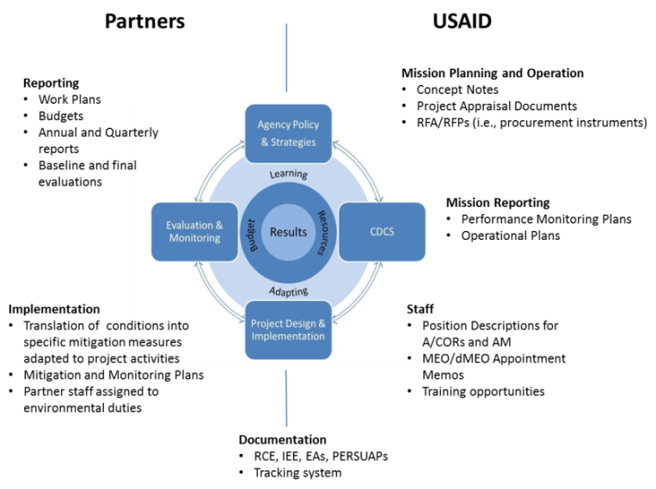

Example Mission Orders and MEO Appointment Memos can be found at: http://www.usaidgems.org/rolesRespons.htm.
http://www.usaid.gov/sites/default/files/documents/1865/204sac.pdf
Audit of Selected USAID Missions’ Efforts to Mitigation Environmental Impact in their Project Portfolios (No. 9-000-11-002-P). http://oig.usaid.gov/sites/default/files/audit-reports/9-000-11-002-p.pdf

